SafarBot

By

Eshan Elahi
22-ARID-3157

Hammad Zahoor
22-ARID-905

Ahan
22-ARID-883

Supervisor
Dr. Farkhanda Qamar

University Institute of Information Technology
PMAS-Arid Agriculture University Rawalpindi
Pakistan-2025
DECLARATION
We hereby declare that this software, neither whole nor as a part has been copied out from any source. It is further declared that we have developed this software documentation and accompanied report entirely on the basis of our personal efforts. If any part of this project is proved to be copied out from any source or found to be reproduction of some other. We will stand by the consequences. No Portion of the work presented has been submitted of any application for any other degree or qualification of this or any other university or institute of learning.

--------------------------- --------------------------- ------------------------
Eshan Elahi Hammad Zahoor Ahan

CERTIFICATE OF APPROVAL
It is to certify that the final year project of BS SE “SafarBot” was developed by “Eshan Elahi, 22-ARID-3157”, “Hammad Zahoor, 22-ARID-905” and “Ahan, 22-ARID-883” under the supervision of “Dr. Farkhanda Qamar” and that in their opinion; it is fully adequate, in scope and quality for the degree of Bachelors of Science in Software Engineering.

---------------------------------------
(Dr. Farkhanda Qamar)
Supervisor

---------------------------------------
(Mr. Suleman Khurram)
Examiner-I

---------------------------------------
(Mr. Asad –ul-haq Hashmi)
Examiner-II

---------------------------------------
Director UIIT
Executive Summary
Online ticket booking systems are widely used today, but many people in Pakistan face challenges using them. Most existing systems are text-based, English-only, and complex, making them difficult for uneducated, elderly, or less tech-savvy users. Additionally, these systems often lack essential features such as fraud detection, real-time travel updates, and instant customer support.
To address these issues, SafarBot has been developed as an AI-powered ticket booking system that is simple, secure, and user-friendly. SafarBot allows users to book tickets via voice or text commands in both Urdu and English, making the platform accessible to a broader audience.
The system incorporates AI-based fraud detection to prevent fake or suspicious bookings and provides real-time travel information, including traffic, weather, and delay updates. A sandbox payment system demonstrates secure transactions.
SafarBot is a web-based application built on the MERN stack, with additional AI services implemented in Python. It features separate dashboards for users, transport providers, and administrators, enabling efficient management of bookings, routes, and system data.
In summary, SafarBot enhances the online ticket booking experience by combining simplicity, security, and intelligent features, making digital travel services accessible and convenient for everyone.

Acknowledgement
All praise is to Almighty Allah who bestowed upon us a minute portion of His boundless knowledge by virtue of which we were able to accomplish this challenging task. We are greatly indebted to our project supervisor “Dr. Farkhanda Qamar” for personal supervision, advice, valuable guidance and completion of this project. We are deeply indebted to her for encouragement and continual help during this work. We are also thankful to our parents and family who have been a constant source of encouragement for us and brought us the values of honesty & hard work.

--------------------------- --------------------------- ------------------------
Eshan Elahi Hammad Zahoor Ahan

Abbreviations
AI | Artificial Intelligence
API | Application Programming Interface
CSS | Cascading Style Sheet
DB | Database
JSON | Javascript Object Notation
HTTPS | Hypertext Transfer Protocol Secure
HTML | HyperText Markup Language
ML | Machine Learning
FR | Functional Requirements
NFR | Non-Functional Requirement
UML | Unified Modeling Language

Table of Contents
CHAPTER 1: INTRODUCTION 1
1.1. Brief 1
1.1.1. Overview of the Project 1
1.1.2. Project Outcomes 1
1.1.3. Tools and Technologies Used 1
1.1.4. Methodology Overview 2
1.2. Relevance to Course Modules 2
1.2.1 Application of Academic Knowledge 2
1.2.2 Course Integration 2
1.2.3 Professional Skill Development 3
1.3. Project Background 3
1.3.1 Motivation 3
1.3.2 Problem Context 3
1.3.3 Project Vision 3
1.4. Literature Review 4
1.4.1 Existing Systems and Research 4
1.4.2 Current Trends 4
1.4.3 Identified Research Gaps 4
1.5. Analysis from Literature Review: 4
1.5.1 Comparative Evaluation 4
1.5.2 Analytical Discussion 5
1.6. Methodology and Software Lifecycle for This Project 5
1.6.1 Rationale behind Selected Methodology 6
CHAPTER 2: PROBLEM DEFINITION 7
2.1 Problem Statement 7
2.1.1 Context of the Problem 7
2.1.2 Identified Challenges 7
2.1.3 Core Problem Definition 8
2.1.4 Expected Outcome 8
2.2 Deliverables and Development Requirements 8
2.2.1 Project Deliverables 8
2.2.2 Development Requirements 9
2.3 Current System (if applicable to your project) 10
2.3.1 Overview of Existing Systems 10
2.3.2 Example of an Existing System 10
2.3.3 Comparative Analysis of Existing vs. Proposed System 11
2.3.4 Observations 12
2.3.5 Summary of Chapter 12
CHAPTER 3: REQUIREMENT ANALYSIS 12
3.1 Use Cases 13
3.1.1 Use Case Diagram 14
3.1.2 Use Case discription 14
3.2 Non-Functional Requirements 31
CHAPTER 4: DESIGN AND ARCHITECTURE 33
4.1 UML Structural Diagrams 33
4.4.1 Component Diagram 33
4.1.2 Package Diagram 34
4.1.3 Deployment Diagram 36
4.1.4 Class Diagram 38
4.1.5 Block Diagram 38
4.2 UML Behavioral Diagrams 39
4.2.1 Activity Diagram 40
4.3 UML Interaction Diagram 45
4.3.1 Sequence Diagram 45
4.3.2 Collaboration Diagram 48
CHAPTER 5: IMPLEMENTATION 50
5.1 Communication Protocol Implementation 50
5.1.1 Component Diagram 51
5.2 Network and Protocol Choice 52
5.2.1 Communication Protocols 52
5.2.2 Security Considerations 53
5.2.3 Performance Optimization 54
5.3 Choice of Object Middleware 55
5.3.1 User Management Module 55
5.3.2 Ticket Booking Module 55
5.3.3 Real Time Travel Insights Module 56
5.4 User Interface 56
CHAPTER 6: TESTING AND EVALUATION 64
6.1 Verification 64
6.1.1 User Module Verification 64
6.1.2 Ticket Booking & Route Module Verification 64
6.1.3 Provider & Notification Module Verification 64
6.1.4 AI Module Verification 65
6.2 Validation 65
6.2.1 User Validation 65
6.2.2 Functional Validation 65
6.2.3 Performance Validation 65
6.3 Usability Testing 66
6.3.1 User Interface Usability 66
6.3.2 Ticket Booking Usability 66
6.3.3 Route & Notification Usability 66
6.3.4 Provider Dashboard Usability 66
6.4 Unit Testing 67
6.4.1 User Registration & Authentication Module 67
6.4.2 Ticket Booking Module 67
6.4.3 Real Time Travel Insights Module 67
6.4.4 Provider Management Module 67
6.4.5 AI Fraud Detection Module 68
6.4.6 Notification Module 68
6.5 Integration Testing 68
6.5.1 User Login & Ticket Booking Integration 68
6.5.2 Ticket Booking & Routes Integration 68
6.5.3 AI Fraud Detection & Booking Integration 69
6.5.4 Provider Management & Booking Integration 69
6.5.5 Notification & Booking Integration 69
6.5.6 Database & Backend Integration 69
6.6 System Testing 69
6.6.1 User Registration & Login Module 70
6.6.2 Ticket Booking Module 70
6.6.3 Route & Map Module 70
6.6.4 Provider Management Module 70
6.6.5 AI Module 70
6.7 Acceptance Testing 71
6.7.1 User Module Acceptance 71
6.7.2 Ticket Booking Acceptance 71
6.7.3 Route Map Acceptance 71
6.7.4 Provider Module Acceptance 71
6.7.5 AI Module Acceptance 71
6.8 Stress Testing 72
6.8.1 High User Load Testing 72
6.8.2 Multiple Booking Requests 72
6.8.3 Notification Load Testing 72
6.8.4 AI Processing Load 72
6.9 Hardware Configuration for Testing 72
6.9.1 Client-Side Hardware 72
6.9.2 Server-Side Hardware 73
6.9.3 Network Requirements 73
6.10 Evaluation 73
6.10.1 System Evaluation – Safarbot 73
6.11 Deployment 74
6.12 Maintenance 74

List of Figures

Figure 2.1 : Sample Picture 10
Figure 3.1: Use Case Diagram 13
Figure 4.1: Component Diagram 33
Figure 4.2:Package Diagram 34
Figure 4.3:Deployment Diagram 35
Figure 4.4:Class Diagram 36
Figure 4.5:Block Diagram 37
Figure 4.6:Activity Diagram: User Registration 38
Figure 4.7:Activity Diagram: Admin Manage Provider 39
Figure 4.8:Activity Diagram: Booking Ticket 40
Figure 4.9:Activity Diagram: Real Time Travel Insights 41
Figure 4.10:Sequence Diagram: Admin Manage User 42
Figure 4.11:Sequence Diagram: User Registration/Login 43
Figure 4.12:Sequence Diagram: Booking Ticket 43
Figure 4.13:Sequence Diagram: Provider Manage Routes 44
Figure 4.14:Sequence Diagram: Real Time Travel Updates 44
Figure 4.15:Collaboration Diagram: User registration/login 45
Figure 4.16:Collaboration Diagram: Admin Manage User 45
Figure 4.17:Collaboration Diagram: Booking Ticket 46
Figure 4.18:Collaboration Diagram: Real Time Travel Updates 46
Figure 4.19:Collaboration Diagram: Provider Manage Routes 47
Figure 5.1:Component Diagram 49
Figure 5.2:Home Page 53
Figure 5.3:About Page 54
Figure 5.4:View Bookings 54
Figure 5.5:Contact Page 55
Figure 5.6:Provider Dashboard 55
Figure 5.7:Routes Manage 56
Figure 5.8:Fraud Alert 56
Figure 5.9:Admin Dashboard 57
Figure 5.10:Manage Provider 57
Figure 5.12:Manage User 58
Figure 5.13:View Reports 58
Figure 5.14:Register Page 59
Figure 5.15:Login Page 59

List of Table
Table 1.1 : Course Integration Table 2
Table 1.2 :Comparison with existing system 5
Table 2.1:Comparison between Existing and Proposed Systems 11
Table 3.1 : UC-1.0 14
Table 3.2: UC-2.0 15
Table 3. 3: UC-3.0 16
Table 3.4: UC-4.0 17
Table 3. 5: UC-5.0 18
Table 3.6: UC-6.0 19
Table 3.7: UC-7.0 20
Table 3.8: UC-8.0 21
Table 3.9: UC-9.0 22
Table 3.10: UC-10.0 23
Table 3.11: UC-11.0 24
Table 3.12: UC-12.0 25
Table 3.13: UC-13.0 26
Table 3.14: UC-14.0 27
Table 3.15: UC-15.0 28
Table 3.16: Functional Requirements Table 30
Table 3.17: Non Functional Requirements Table 31

CHAPTER 1: INTRODUCTION
This chapter gives a complete overview of the SafarBot project — a smart, AI-powered web application designed to make online ticket booking easier, especially for people who are uneducated or less familiar with digital systems. It explains the background, goals, methodology, and connection to the subjects studied during the degree.

Brief

Overview of the Project
SafarBot is an AI-integrated web-based transport ticket booking system developed using the MERN stack. The system enables users to book intercity transport tickets through voice or text commands in both Urdu and English, making the platform accessible to a wider audience, including elderly and less-educated users.
The platform incorporates AI-powered fraud detection and real-time travel insights to assist users throughout the booking process. SafarBot aims to eliminate complexity, enhance security, and improve accessibility in online ticket booking systems.

Project Outcomes
Voice-enabled ticket booking system (Urdu & English).
• AI-based fraud detection for suspicious bookings.
• Real-time travel insights (traffic & weather).
• Secure and transparent digital payment system.
• Accessible platform for low-literacy users.

Tools and Technologies Used
The project uses modern software tools and technologies:
- Front-end: React.js, HTML5, CSS3, JavaScript
- Back-end: Node.js, Express.js
- Database: MongoDB (MongoDB Atlas)
- AI Components: Python, FastAPI (Fraud Detection & Insights)
- Voice Processing: Speech-to-Text APIs
- Payment Gateway: JazzCash / Easypaisa (Sandbox)
- Deployment: Vercel, Render

Methodology Overview
The system is being developed using the Agile Software Development Methodology, which divides the project into short, iterative sprints. Each sprint focuses on developing a specific functional module and is followed by review and user feedback to ensure continuous improvement.

Relevance to Course Modules

Application of Academic Knowledge
This Final Year Project (FYP) is directly related to several core and elective courses studied during the BS Software Engineering degree. It demonstrates how theoretical knowledge gained throughout the program is applied to solve real-world problems.

Course Integration
Table 1.1 : Course Integration Table
Course Name | Relevance to Project
Artificial Intelligence | Development of machine learning models for fraud detection and predictive insights
Web Engineering & Mobile App Management | Design and implementation of front-end and back-end web modules.
Database Systems | Structuring, storing, and managing booking and user data management.
Software Project Management | Sprint planning, Agile process management, and risk assessment.
Software Design & Architecture | Modular and scalable system architecture using object-oriented principles.
Software Quality Assurance | Testing of system functionality, performance, and reliability.
Human-Computer Interaction (HCI) | Designing an intuitive, user-friendly interface for users.

Professional Skill Development
The project enhances problem-solving, teamwork, version control, and real-world analytical thinking—skills vital for a software engineer. It bridges the gap between classroom learning and practical field implementation.

Project Background

Motivation
In Pakistan, online ticket booking platforms such as BookMe.pk and Bookaru are widely used but remain inaccessible to many individuals due to language barriers, complex interfaces, and limited automation. Elderly and low-literacy users often struggle with text-heavy systems and lack of real-time assistance.
This challenge motivated the development of SafarBot—an AI-driven, voice-enabled booking system designed to simplify ticket booking while ensuring security and inclusivity.

Problem Context
Existing booking systems focus mainly on manual searches and payment processing, offering limited real-time insights and weak fraud prevention. Additionally, the absence of voice-based interaction restricts usability for a large segment of the population. SafarBot addresses these issues by integrating AI automation, fraud detection, and real-time intelligence into a single platform.

Project Vision
The vision of SafarBot is to create an intelligent and inclusive transport booking ecosystem where users can interact naturally through voice, receive instant assistance, and complete secure bookings with confidence. The platform aims to bridge the gap between technology and accessibility across all social groups.

Literature Review

Existing Systems and Research
• BookMe.pk: Provides online ticket booking but lacks AI automation and voice support
• Bookaru: Offers basic transport booking with limited intelligence

Current Trends
Modern booking platforms emphasize:
- Conversational AI and chatbots.
- Real-time travel and traffic insights.
- AI-based fraud prevention.
- Cloud-hosted scalable architectures.
- Accessibility-focused UI/UX design.

Identified Research Gaps
Most existing platforms lack:
• Voice-based bilingual interaction
• AI-driven fraud detection
• Integrated real-time travel intelligence
• Inclusive design for low-literacy users

Analysis from Literature Review:

Comparative Evaluation
Table 1.2 :Comparison with existing system
Feature | Existing Apps | SafarBot (Proposed)
Online Booking | Yes | Yes
Voice Interaction | No | Yes
AI Chatbot | Limited | Yes
Fraud Detection | No | Yes
Real-Time Insights | Limited | Yes

Analytical Discussion
The analysis indicates that current systems prioritize booking functionality while neglecting automation, security, and inclusivity. SafarBot introduces AI-powered voice interaction, fraud detection, and real-time intelligence, creating a smarter and more user-centric booking solution aligned with modern technological trends.

Methodology and Software Lifecycle for This Project
The Agile Software Development Life Cycle (SDLC) has been adopted for this project due to its iterative and adaptive nature. It divides development into multiple sprints—each delivering incremental progress while maintaining flexibility to incorporate user feedback.
Implementation Strategy
Each sprint will focus on a core functionality:
- Sprint 1: Requirement gathering and UI/UX prototyping
- Sprint 2: User authentication and booking modules
- Sprint 3: Voice interaction integration
- Sprint 4: AI fraud detection and real-time insights
- Sprint 5: Testing, optimization, and deployment
Benefits of Agile for This Project
- Continuous testing and improvement
- Rapid identification of issues
- Flexibility for design and AI model enhancements
- Regular client/supervisor feedback integration

Rationale behind Selected Methodology
The Agile model was selected because:
- The system involves evolving requirements (especially for AI and GIS integration).
- It allows continuous feedback from supervisors and potential end-users.
- Each feature can be tested independently, ensuring stability.
- The iterative process supports parallel development of AI, web, and database modules

Rationale behind Selected Methodology
The system architecture follows Object-Oriented and modular principles:
• Reusable components such as User, Booking, Payment, and FraudModel
• Improved scalability for future enhancements
• Easier maintenance and feature expansion
Combining Agile methodology with modular system design provides both development flexibility and architectural robustness, making it suitable for an AI-driven, real-time booking platform like SafarBot.

CHAPTER 2: PROBLEM DEFINITION
This chapter defines the core problem addressed by SafarBot. It explains the nature of issues present in existing online ticket booking systems in Pakistan, the objectives of solving these issues, and the project deliverables. It also discusses current systems, highlighting their limitations and how the proposed SafarBot system overcomes them.

Problem Statement

Context of the Problem
In Pakistan, online ticket booking platforms such as BookMe.pk and Bookaru are widely used for intercity transport reservations. However, these systems are primarily designed for users who are literate, technologically skilled, and comfortable with English-based, text-heavy interfaces.
A large segment of the population—including elderly individuals, uneducated users, and people with language barriers—faces difficulties in searching routes, entering information, and completing bookings. Additionally, existing platforms lack intelligent automation, real-time travel updates, and effective fraud prevention mechanisms, which reduces user trust and system reliability.

Identified Challenges
• Text-based interfaces that are difficult for uneducated and elderly users
• No support for voice-based booking or Urdu language interaction
• Absence of AI-based fraud detection for fake or duplicate bookings
• Lack of real-time updates related to traffic, weather, or travel delays
• Manual and slow customer support services
• No safe sandbox environment for testing payment workflows

Core Problem Definition
The current online ticket booking systems in Pakistan are inaccessible, insecure, and poorly automated. These limitations result in usability issues, customer dissatisfaction, and operational inefficiencies for transport providers.
SafarBot aims to address these problems by developing an AI-powered, voice-enabled booking platform capable of:
• Voice and text-based ticket booking in Urdu and English
• AI-based fraud detection to identify suspicious bookings
• Real-time travel insights including weather and traffic conditions
• Automated customer assistance through intelligent AI support
• A secure and accessible booking environment for all users

Expected Outcome
The expected outcome of the SafarBot project is a smart, secure, and inclusive ticket booking system that improves accessibility, trust, and efficiency. The system will reduce booking errors, prevent fraud, enhance user experience, and provide transport providers with better operational control.

Deliverables and Development Requirements

Project Deliverables
The deliverables of the SafarBot project include both functional software components and supporting documentation.
Main Deliverables:
- Web Application Platform – MERN stack-based system for transport ticket booking
- AI Voice Agent – Voice-based booking using Urdu and English commands
- AI Fraud Detection Module – Identification of fake, duplicate, or suspicious bookings.
- AI Real-Time Insights System – Live updates on traffic, weather, and delays.
- Payment Sandbox Integration – JazzCash/Easypaisa test environment for secure demos.
- Admin & Provider Panels – Route management, booking monitoring, and fraud alerts
- Documentation –
- Software Requirement Specification (SRS)
- System Design Diagrams (UML, ERD, Use Case)
- Testing and Evaluation Report
Final Project Report and Presentation

Development Requirements
Hardware Requirements:
• Laptop or PC with minimum 8 GB RAM
• 250 GB storage or higher
• Stable internet connection
• Microphone for voice input testing
Software Requirements:
• Frontend: React.js, Tailwind CSS
• Backend: Node.js, Express.js
• Database: MongoDB Atlas
• AI Libraries: TensorFlow, Scikit-learn, Hugging Face Transformers
• Payment Sandbox: JazzCash / Easypaisa Test Mode
• Deployment: Vercel (Frontend), Render/Heroku (Backend)
Development Tools:
• Visual Studio Code
• Postman (API Testing)
• Figma (UI/UX Design)
• GitHub (Version Control)
Team Requirements:
- 3 Developers (team members)
- 1 Supervisor for technical guidance

Current System (if applicable to your project)

Overview of Existing Systems
Current online ticket booking systems in Pakistan, such as BookMe.pk and Bookaru, allow users to reserve seats for buses, trains, and events. These platforms focus mainly on booking and payment functionality but lack intelligent automation and accessibility features.
Limitations of Existing Systems:
• Entirely text-based user interaction
• Manual customer support
• No voice or Urdu language support
• No AI-based fraud prevention
• No real-time travel alerts

Example of an Existing System
Figure 2.1 illustrates a sample interface of a current online ticket booking system, highlighting its text-heavy layout and limited accessibility.

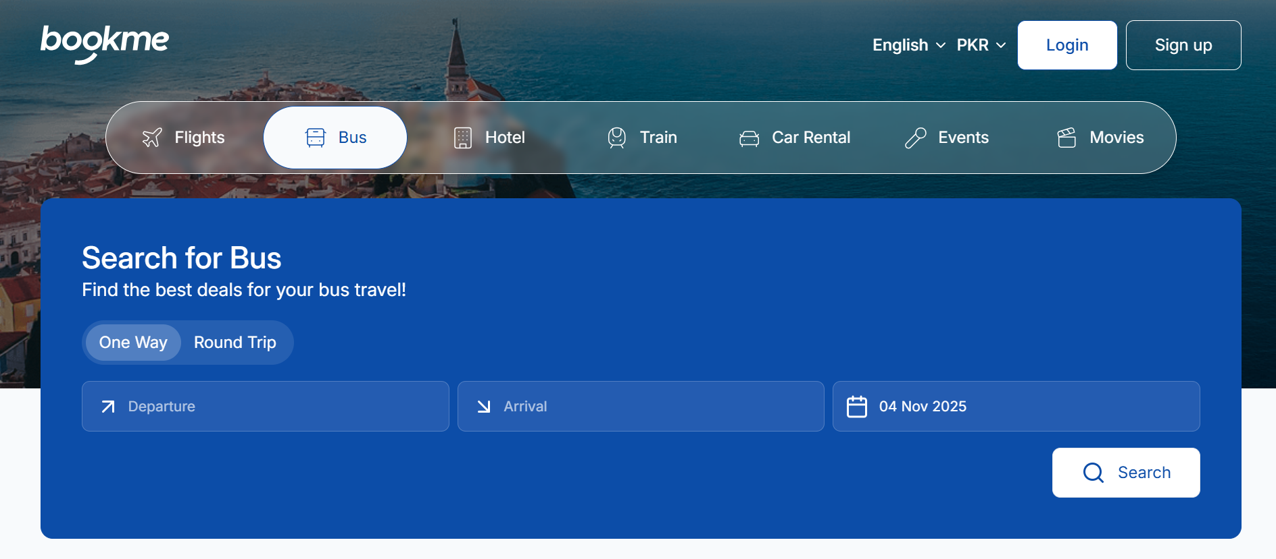
Figure 2.1 : Sample Picture

Comparative Analysis of Existing vs. Proposed System
Table 2.1:Comparison between Existing and Proposed Systems
Feature | BookMe / Bookaru | SafarBot
User Interaction | Text only | Voice + Text (Urdu/English)
Fraud Detection | Not available | AI-based fraud detection
Real-Time Insights | Not available | Weather & traffic-based insights
Customer Support | Manual chat | AI chatbot with auto-escalation
Payment Integration | Live Payments | Sandbox (safe demo)
Accessibility | For educated users only | For all, including uneducated users

Observations
The comparison clearly shows that existing systems are functional but lack intelligence, accessibility, and security. SafarBot enhances the booking experience by integrating AI-driven automation, voice interaction, fraud detection, and real-time insights into a single unified platform. This transformation shifts ticket booking from a manual and restrictive process to a smart and user-centric system.

Summary of Chapter
This chapter identified the main problems in existing online ticket booking systems in Pakistan, including accessibility issues, lack of automation, and security concerns. It outlined the proposed solution—SafarBot—along with its deliverables, development requirements, and comparison with current systems. The next chapter will present a detailed Literature Review, analyzing existing research and technologies related to AI-based booking and voice-enabled systems.

CHAPTER 3: REQUIREMENT ANALYSIS
This chapter outlines the Software Requirements Specification (SRS) for SafarBot. It identifies the system’s use cases, actors, and their interactions with the platform. The SRS serves as a foundation for system design, development, implementation, and testing throughout the software development lifecycle.
SafarBot is an AI-powered, voice-enabled transport ticket booking system designed to improve accessibility, security, and efficiency in online ticket booking, especially for users in Pakistan.

Use Cases
Use cases define the functional interactions between the system and its users (actors), illustrating how specific goals are achieved through a sequence of actions. In the SafarBot platform, multiple actors are involved, each with distinct roles and responsibilities, including Passenger (Customer), Service Provider, and Administrator. These actors interact with the system to perform operations that collectively support the core functionality of the platform.
Passengers primarily use the system to register and authenticate, search available routes and schedules, book tickets, make payments, manage bookings, and receive real-time notifications. Additionally, passengers may interact with AI-driven features such as chatbot or voice-based assistance to obtain travel information and support.
Service Providers interact with SafarBot to create and manage routes, define schedules, set pricing, monitor bookings, and analyze operational insights through reports and dashboards. These actions enable providers to efficiently manage transportation services and optimize resource utilization.
Administrators oversee the overall system operations by managing users and providers, monitoring bookings and transactions, handling fraud alerts, and enforcing system policies and permissions. The admin role ensures system security, data integrity, and smooth platform operation.
Together, these use cases provide a comprehensive view of system functionality from the perspective of each actor, serving as a foundation for requirement analysis, system design, and validation. By clearly defining actor interactions, the use-case model helps ensure that SafarBot meets functional requirements while supporting scalability, security, and intelligent, real-time booking operations.
The following use cases capture the major functionalities and interactions that define the overall behavior of the system.

Use Case Diagram

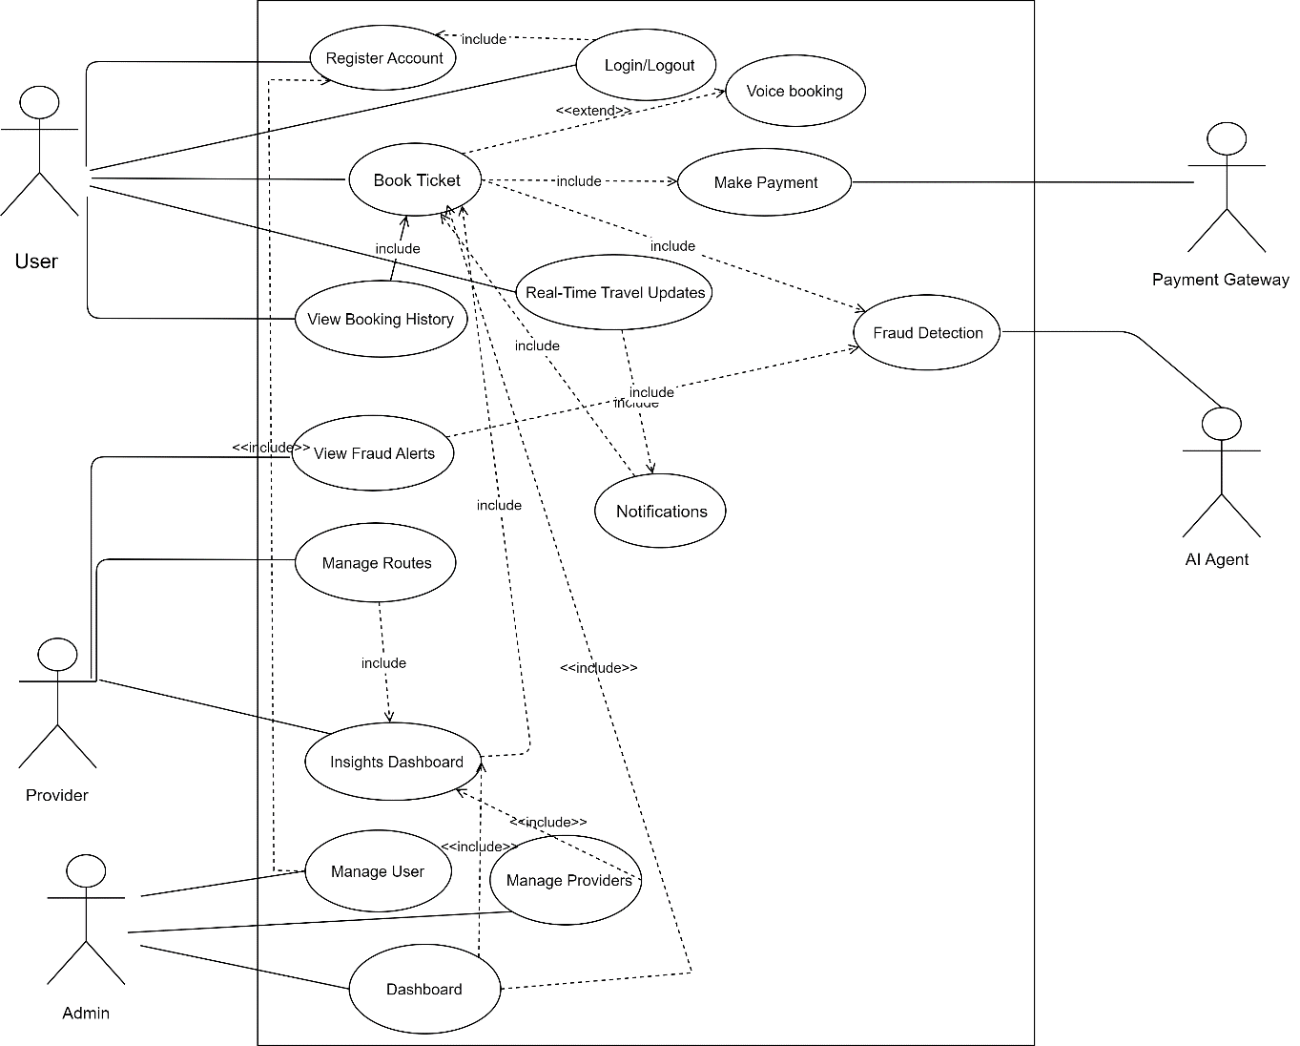
Figure 3.1: Use Case Diagram

Use Case description
Table 3.1 : UC-1.0
Use Case ID: | UC-1.0
Use Case Name: | Register Account
Actors: | User, System Database
Description: | Enables a new user to create an account in the SafarBot system by providing basic personal information such as name, email, and password. The system validates the input and stores it securely in the database.
Trigger: | User selects the “Register” option.
Preconditions: | User is not already registered and has an active internet connection.
Postconditions: | A new user account is created and a confirmation message is displayed.
Normal Flow: | - User opens the registration page.  - User enters required personal details.  - System validates the entered data.  - System stores the information in the database.  - System confirms successful registration.
Alternative Flows: | If the email already exists, the system prompts the user to log in.
Exceptions: | Network or database failure during registration.
Includes: | None.
Special Requirements: | Secure password storage.
Assumptions: | User has a valid email address.
Notes and Issues: | None.

Table 3.2: UC-2.0
Use Case ID: | UC-2.0
Use Case Name: | Login/Logout
Actors: | User, Provider, Admin, Authentication System
Description: | Authenticates registered users and allows them to access or exit the system securely.
Trigger: | User enters login credentials or selects logout.
Preconditions: | User account exists in the system.
Postconditions: | User session is started or terminated.
Normal Flow: | - User enters email and password.  - System verifies credentials.  - System grants access and redirects to dashboard.
Alternative Flows: | Invalid credentials result in an error message.
Exceptions: | Authentication service unavailable.
Includes: | UC-1.0 (Register Account)
Special Requirements: | Secure session management.
Assumptions: | Credentials are valid.
Notes and Issues: | Multi-factor authentication may be added later.

Table 3. 3: UC-3.0
Use Case ID: | UC-3.0
Use Case Name: | Book Ticket
Actors: | User, Provider system
Description: | Allows users to search available routes, select seats, and book tickets using the SafarBot system.
Trigger: | User initiates ticket booking.
Preconditions: | User must be logged in.
Postconditions: | Ticket booking is confirmed and stored.
Normal Flow: | - User searches for routes.  - User selects route and seat.  - System confirms booking details.  - User proceeds to payment.
Alternative Flows: | No seats available; system suggests alternatives.
Exceptions: | Route data unavailable.
Includes: | UC-2.0 (User Login)
Special Requirements: | Seat availability synchronization.
Assumptions: | Route data is up to date.
Notes and Issues: | High concurrency must be handled.

Table 3.4: UC-4.0
Use Case ID: | UC-4.0
Use Case Name: | Voice Booking
Actors: | User, AI Voice Agent
Description: | Enables users to book tickets using voice commands with AI assistance.
Trigger: | User initiates voice interaction.
Preconditions: | User is logged in and microphone access is available.
Postconditions: | Ticket is booked successfully.
Normal Flow: | - User provides booking details via voice.  - AI interprets commands.  - System completes booking process.
Alternative Flows: | AI asks user to repeat unclear input.
Exceptions: | Voice recognition failure.
Extends: | UC-3.0 (Book Ticket)
Special Requirements: | Speech-to-text support.
Assumptions: | Clear voice input.
Notes and Issues: | Urdu accent accuracy needs testing.

Table 3. 5: UC-5.0
Use Case ID: | UC-5.0
Use Case Name: | Make Payment
Actors: | User, Payment Gateway
Description: | Processes ticket payment through an external payment gateway.
Trigger: | User confirms booking.
Preconditions: | Valid booking exists.
Postconditions: | Payment is completed or declined.
Normal Flow: | - User selects payment method.  - System redirects to payment gateway.  - Transaction is processed.  - System confirms payment status.
Alternative Flows: | User cancels payment.
Exceptions: | Gateway timeout or failure.
Includes: | UC-3.0 (Book Ticket)
Special Requirements: | Secure transaction handling.
Assumptions: | Payment gateway is operational.
Notes and Issues: | Sandbox used during development.

Table 3.6: UC-6.0
Use Case ID: | UC-6.0
Use Case Name: | View Booking History
Actors: | User
Description: | Allows users to view previous and upcoming bookings.
Trigger: | User selects “Booking History.”
Preconditions: | User is logged in.
Postconditions: | Booking history is displayed.
Normal Flow: | - User requests booking history.  - System retrieves records.  - System displays booking details.
Alternative Flows: | None.
Exceptions: | Database access error.
Includes: | None.
Special Requirements: | Pagination for large datasets.
Assumptions: | Booking records exist.
Notes and Issues: | None.

Table 3.7: UC-7.0
Use Case ID: | UC-7.0
Use Case Name: | Real-Time Travel Updates
Actors: | User, System
Description: | Provides live updates related to routes, delays, or schedule changes.
Trigger: | System detects change in travel status.
Preconditions: | Active booking exists.
Postconditions: | User receives updates.
Normal Flow: | - System monitors route status.  - Update is detected.  - User is notified.
Alternative Flows: | None.
Exceptions: | None.
Includes: | UC-8.0 (Notifications)
Special Requirements: | Real-time data integration.
Assumptions: | External data sources are reliable.
Notes and Issues: | Duplicate alerts should be avoided.

Table 3.8: UC-8.0
Use Case ID: | UC-8.0
Use Case Name: | Send Notifications
Actors: | System
Description: | Sends automated alerts related to bookings, payments, and travel updates
Trigger: | System event occurs.
Preconditions: | Notification trigger exists.
Postconditions: | Notification is delivered.
Normal Flow: | - Event is triggered.  - Notification is generated.  - User receives alert.
Alternative Flows: | None.
Exceptions: | Notification service unavailable.
Includes: | None.
Special Requirements: | Multi-channel support.
Assumptions: | User notifications are enabled.
Notes and Issues: | None.

Table 3.9: UC-9.0
Use Case ID: | UC-9.0
Use Case Name: | Fraud Detection
Actors: | AI Agent
Description: | Detects suspicious booking or payment activities using AI analysis.
Trigger: | Booking is initiated.
Preconditions: | Access to booking data.
Postconditions: | Fraud alert generated if needed.
Normal Flow: | - AI analyzes booking.  - Suspicious patterns identified.  - Alert is generated.
Alternative Flows: | None.
Exceptions: | AI service unavailable.
Includes: | None.
Special Requirements: | ML model monitoring.
Assumptions: | Historical data exists.
Notes and Issues: | False positives possible.

Table 3.10: UC-10.0
Use Case ID: | UC-10.0
Use Case Name: | View Fraud Alerts
Actors: | Provider
Description: | Allows provider to view fraud alerts generated by the system.
Trigger: | Provider opens fraud alerts section.
Preconditions: | Provider is logged in.
Postconditions: | Fraud alerts displayed.
Normal Flow: | - Provider requests fraud alerts.  - System retrieves alerts.  - Alerts are shown.
Alternative Flows: | None.
Exceptions: | None.
Includes: | UC-9.0 (Fraud Detection)
Special Requirements: | None.
Assumptions: | None.
Notes and Issues: | Alert prioritization may be added later.

Table 3.11: UC-11.0
Use Case ID: | UC-11.0
Use Case Name: | Manage Routes
Actors: | Provider
Description: | Enables providers to add, update, or remove bus routes.
Trigger: | Provider accesses route management.
Preconditions: | Provider is authenticated.
Postconditions: | Route data updated.
Normal Flow: | - Provider adds or edits route.  - System validates data.  - Changes are saved.
Alternative Flows: | None.
Exceptions: | Invalid route information.
Includes: | None.
Special Requirements: | None.
Assumptions: | None.
Notes and Issues: | Admin approval may be required later.

Table 3.12: UC-12.0
Use Case ID: | UC-12.0
Use Case Name: | Insights Dashboard
Actors: | Provider
Description: | Displays analytics related to bookings, revenue, and system usage.
Trigger: | Provider opens dashboard.
Preconditions: | Data exists.
Postconditions: | Insights displayed.
Normal Flow: | - Dashboard is accessed.  - Data is fetched.  - Charts and metrics are displayed.
Alternative Flows: | None.
Exceptions: | None.
Includes: | None.
Special Requirements: | None.
Assumptions: | None.
Notes and Issues: | AI predictions can be added later.

Table 3.13: UC-13.0
Use Case ID: | UC-13.0
Use Case Name: | Manage Users
Actors: | Admin
Description: | Allows admin to manage user accounts.
Trigger: | Admin selects user management.
Preconditions: | Admin is logged in.
Postconditions: | User records updated.
Normal Flow: | - Admin views users.  - Admin edits or removes user.  - System confirms update.
Alternative Flows: | None.
Exceptions: | None.
Includes: | None.
Special Requirements: | None.
Assumptions: | None.
Notes and Issues: | Privacy compliance required.

Table 3.14: UC-14.0
Use Case ID: | UC-14.0
Use Case Name: | Manage Providers
Actors: | Admin
Description: | Allows admin to manage transport service providers.
Trigger: | Admin selects provider management.
Preconditions: | Admin authentication required.
Postconditions: | Provider data updated.
Normal Flow: | - Admin views provider list.  - Admin updates provider details.  - System saves changes.
Alternative Flows: | None.
Exceptions: | None.
Includes: | None.
Special Requirements: | None.
Assumptions: | None.
Notes and Issues: | Provider verification needed.

Table 3.15: UC-15.0
Use Case ID: | UC-15.0
Use Case Name: | Admin Dashboard
Actors: | Admin
Description: | Provides a centralized interface for monitoring and controlling the SafarBot system.
Trigger: | Admin logs into dashboard.
Preconditions: | Admin is authenticated.
Postconditions: | System overview displayed.
Normal Flow: | - Admin accesses dashboard.  - System loads statistics and controls.  - Admin monitors system status.
Alternative Flows: | None.
Exceptions: | None.
Includes: | None.
Special Requirements: | None.
Assumptions: | None.
Notes and Issues: | Role-based widgets may be added.

3.2 Functional Requirements
The functional requirements define the system behavior in response to user actions.
Table 3.16: Functional Requirements Table
ID | Requirement Description
FR-1 | The system shall allow users to register and log in using valid credentials.
FR-2 | The system shall allow users to book transport tickets using text-based input.
FR-3 | The system shall allow users to book transport tickets using voice commands in Urdu and English.
FR-4 | The system shall display available routes, schedules, and seat availability in real time.
FR-5 | The system shall process ticket payments using a sandbox payment gateway (JazzCash/Easypaisa).
FR-6 | The system shall provide booking confirmation and maintain booking history for users.
FR-7 | The system shall send automated notifications for booking confirmation, cancellation, and travel updates.
FR-8 | The system shall provide real-time travel insights including traffic, weather, and delay information.
FR-9 | The system shall detect suspicious or fraudulent booking activities using AI-based models.
FR-10 | The system shall display fraud alerts on the provider dashboard for review.
FR-11 | The system shall allow transport providers to add, update, or remove routes and schedules.
FR-12 | The system shall provide analytical dashboards for providers and administrators.
FR-13 | The system shall allow administrators to manage users, providers, and system configurations.

Non-Functional Requirements
The non-functional requirements (NFRs) define system quality, performance, and constraints.
Table 3.17: Non Functional Requirements Table
Category | Requirement Description
Performance | The system shall respond to user requests within 3 seconds under normal operating conditions.
Scalability | The system shall support at least 5,000 concurrent users during peak usage periods.
Security | All sensitive user data shall be encrypted, and authentication shall use JWT-based security mechanisms.
Usability | The user interface shall be intuitive and accessible for uneducated and elderly users.
Reliability | The system shall maintain a minimum uptime of 99% during operation.
Maintainability | The system shall use a modular architecture to allow easy maintenance and upgrades.
Compatibility | The system shall be compatible with modern web browsers and mobile devices.
Availability | The platform shall be available 24/7 using cloud-based deployment infrastructure.
Accuracy | The AI fraud detection module shall maintain an accuracy of at least 80% on test datasets.
Localization | The system shall support both Urdu and English for text and voice-based interaction.

CHAPTER 4: DESIGN AND ARCHITECTURE
This chapter explains the overall architecture and internal design of the SafarBot, including system components, interactions, and the design patterns used.

UML Structural Diagrams
UML Structural Diagrams describe what the system is made of, not how it behaves. UML Structural Diagrams represent the static layout and structure of a system and the relationships between its components.

Component Diagram
A UML diagram that shows the high-level system components and their dependencies, illustrating how different modules interact to form the complete system.
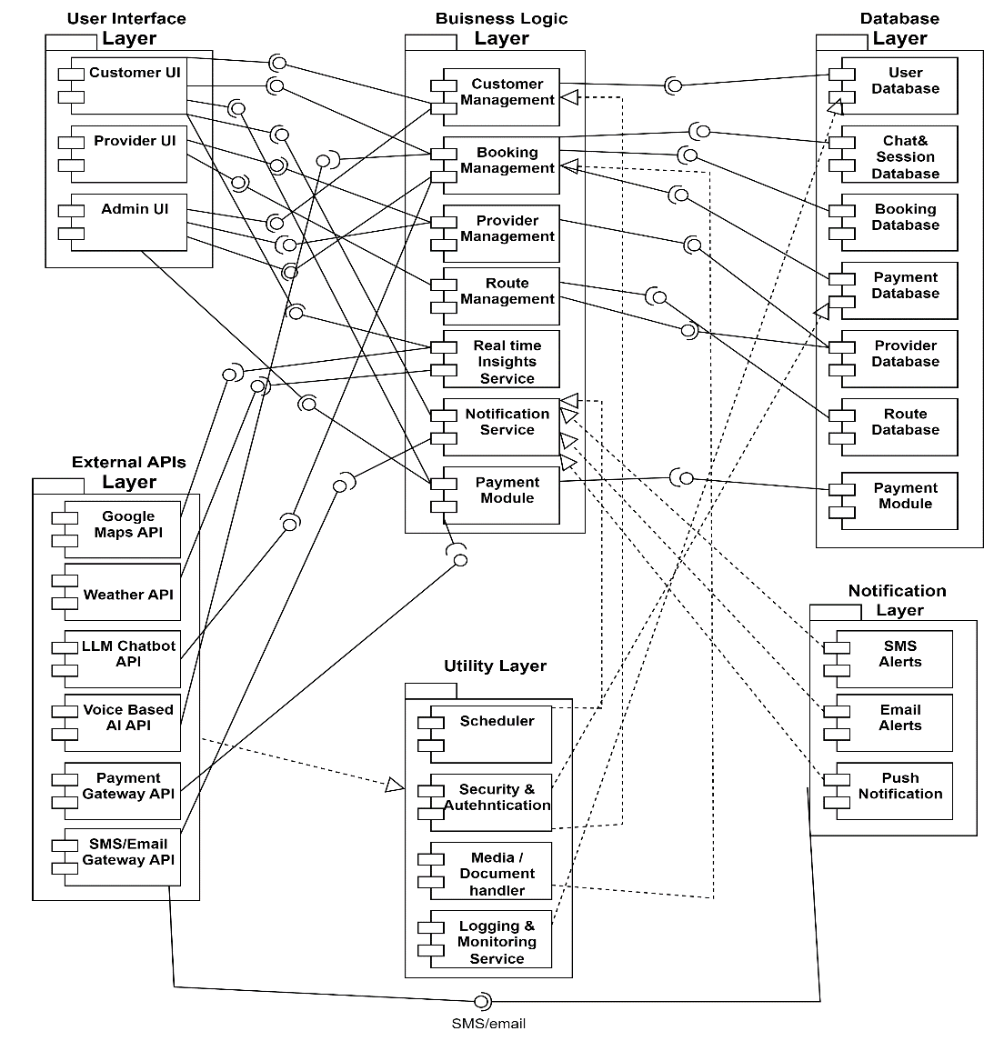
Figure 4.1: Component Diagram

Package Diagram
A UML diagram that organizes related classes and components into packages, showing the structural grouping and dependency relationships within the system.

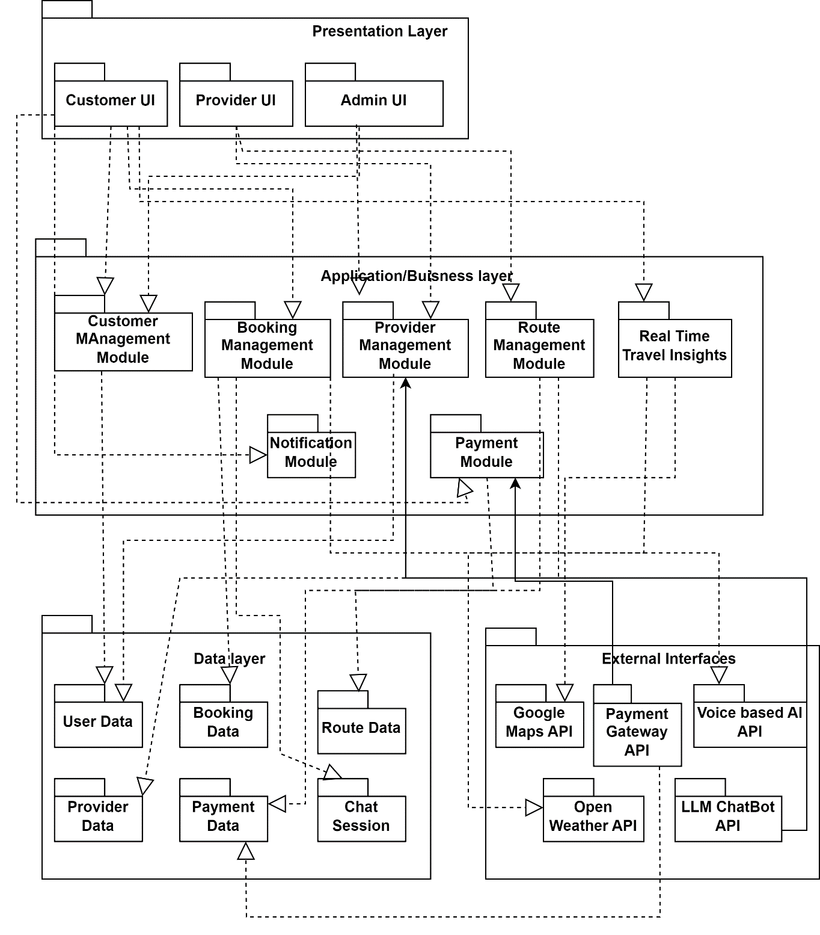
Figure 4.2:Package Diagram

Deployment Diagram
A Deployment Diagram is a UML diagram that shows the physical arrangement of hardware and software in a system, illustrating where system components are deployed and how they communicate.
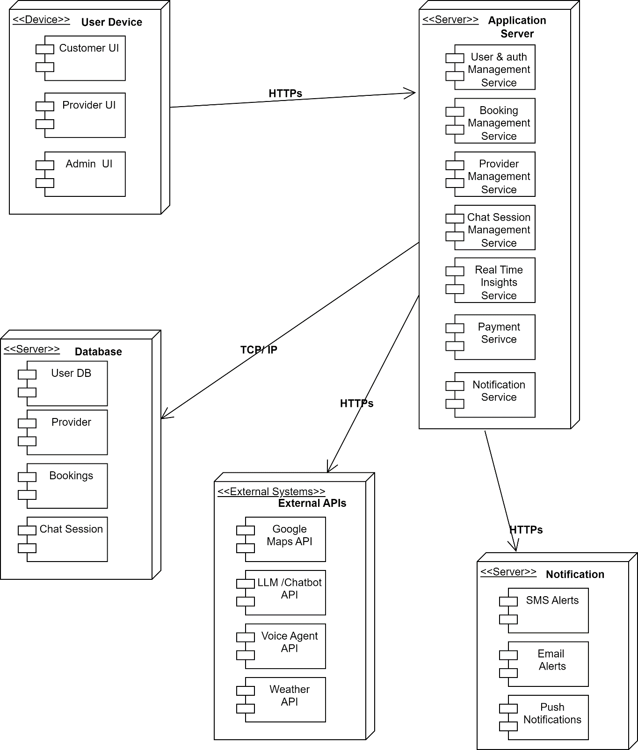
Figure 4.3:Deployment Diagram

Class Diagram
A Class Diagram is a UML diagram that shows the classes of a system along with their attributes, functions, and the relationships between them, helping to model the system’s structure.

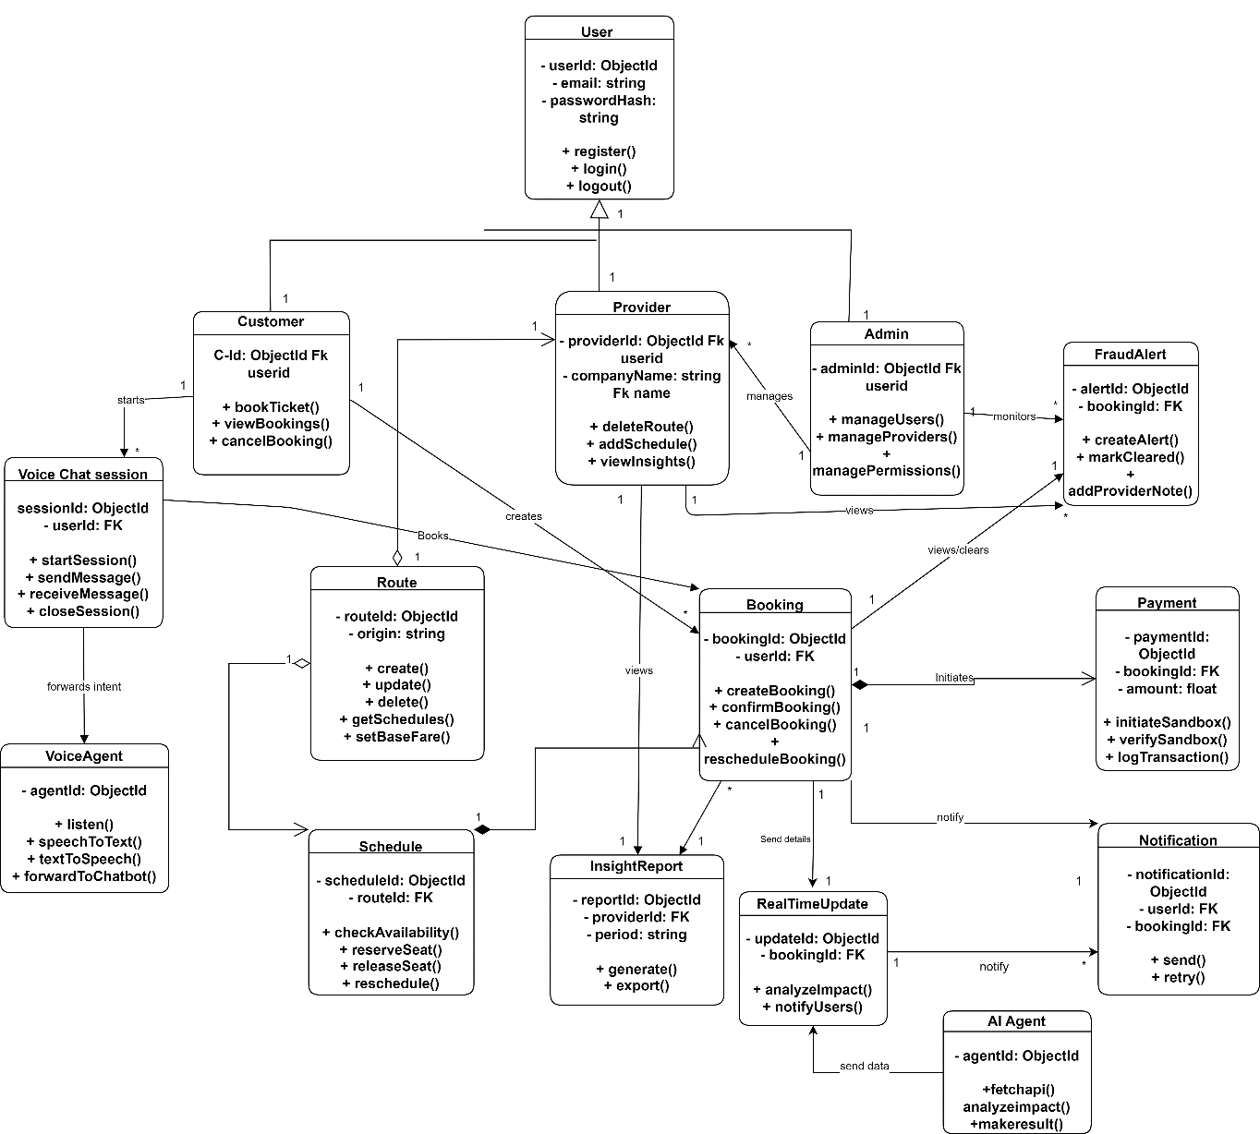

Figure 4.4:Class Diagram

Block Diagram
A block diagram is a simple and high-level visual representation of a system that illustrates its main components (blocks) and the relationships or connections between them. Each block represents a major function or subsystem rather than detailed internal workings. The connections between blocks show the flow of information, signals, data, or control from one component to another. Block diagrams are commonly used in engineering, computer science, and system design to provide a clear overview of how a system operates. They help designers, developers, and stakeholders quickly understand the system’s structure without getting into technical details. Because of their simplicity, block diagrams are especially useful during the initial planning and analysis stages of a project.

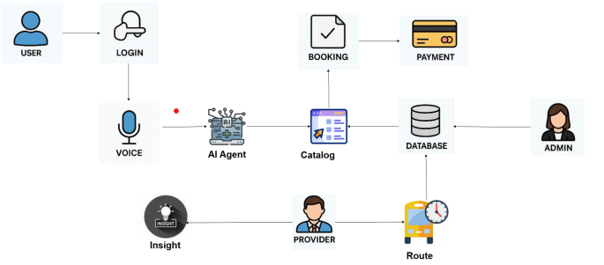
Figure 4.5:Block Diagram

UML Behavioral Diagrams
A UML Behavioral Diagram is used to represent the dynamic behavior of a system, showing how the system and its components interact, respond, and change over time. Unlike structural diagrams, which focus on what the system is made of, behavioral diagrams focus on how the system behaves when it is running. These diagrams illustrate user interactions, workflows, message exchanges, state changes, and control flow within the system.

Activity Diagram
An Activity Diagram is a UML behavioral diagram that visually represents the step-by-step flow of activities in a system, showing how processes begin, branch, merge, and end through actions, decisions, and parallel flows. It helps in understanding the dynamic behavior of the system by clearly illustrating workflow logic, control flow, and the sequence of operations. Additionally, activity diagrams are useful for analyzing business processes and use-case scenarios, making system behavior easier to communicate to both technical and non-technical stakeholders.

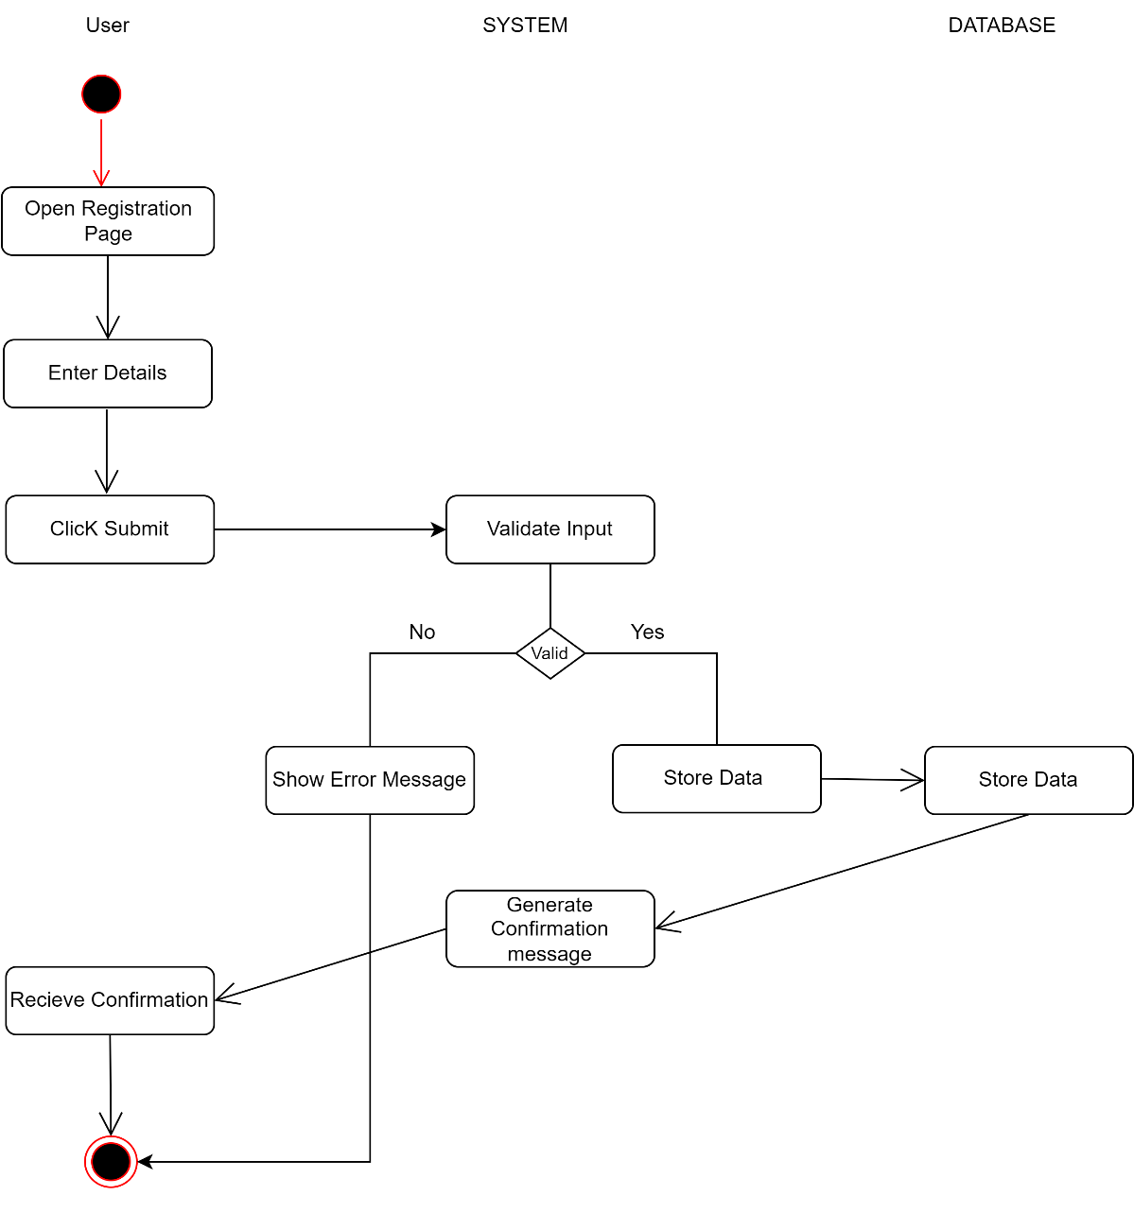
Figure 4.6:Activity Diagram: User Registration
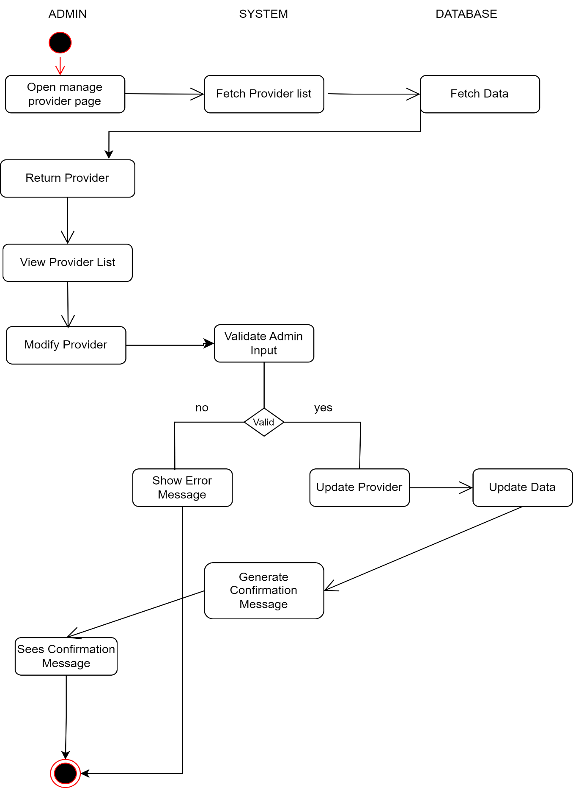
Figure 4.7:Activity Diagram: Admin Manage Provider
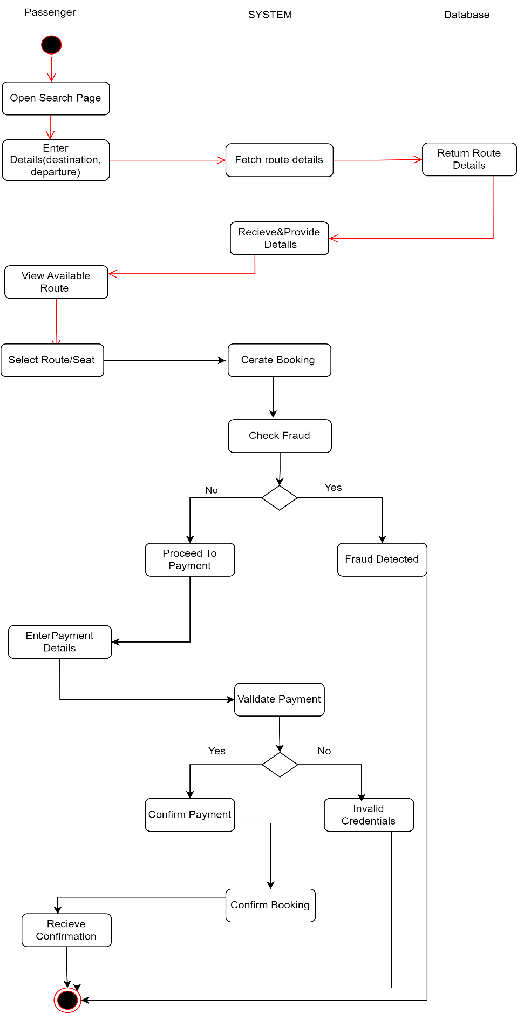
Figure 4.8:Activity Diagram: Booking Ticket
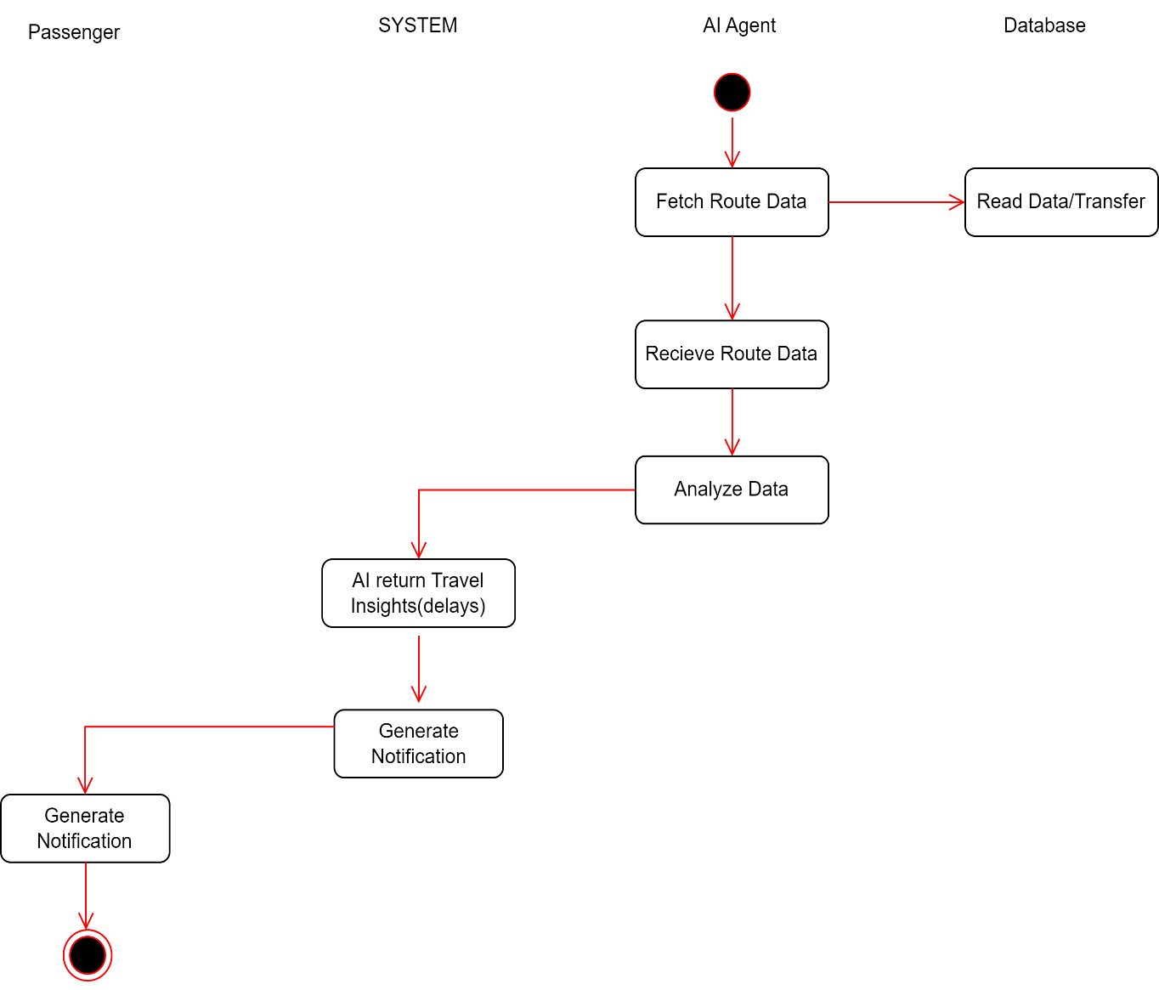

Figure 4.9:Activity Diagram: Real Time Travel Insights

UML Interaction Diagram
A UML Interaction Diagram is used to show how different objects or components communicate with each other within a system to accomplish a specific task. It focuses on the exchange of messages between system elements and helps explain the dynamic behavior of the system at runtime. Interaction diagrams describe the order, flow, and type of interactions that occur during processes such as login, data processing, analysis, or result generation.

Sequence Diagram
Sequence Diagram is a UML diagram that shows how different objects or system parts interact with each other by sending messages in a step-by-step, time-ordered sequence.it explains the step-by-step flow of messages between the user, system components, and database in the order they occur. The diagram is drawn from top to bottom, where time flows downward, making it easy to understand the sequence of actions.

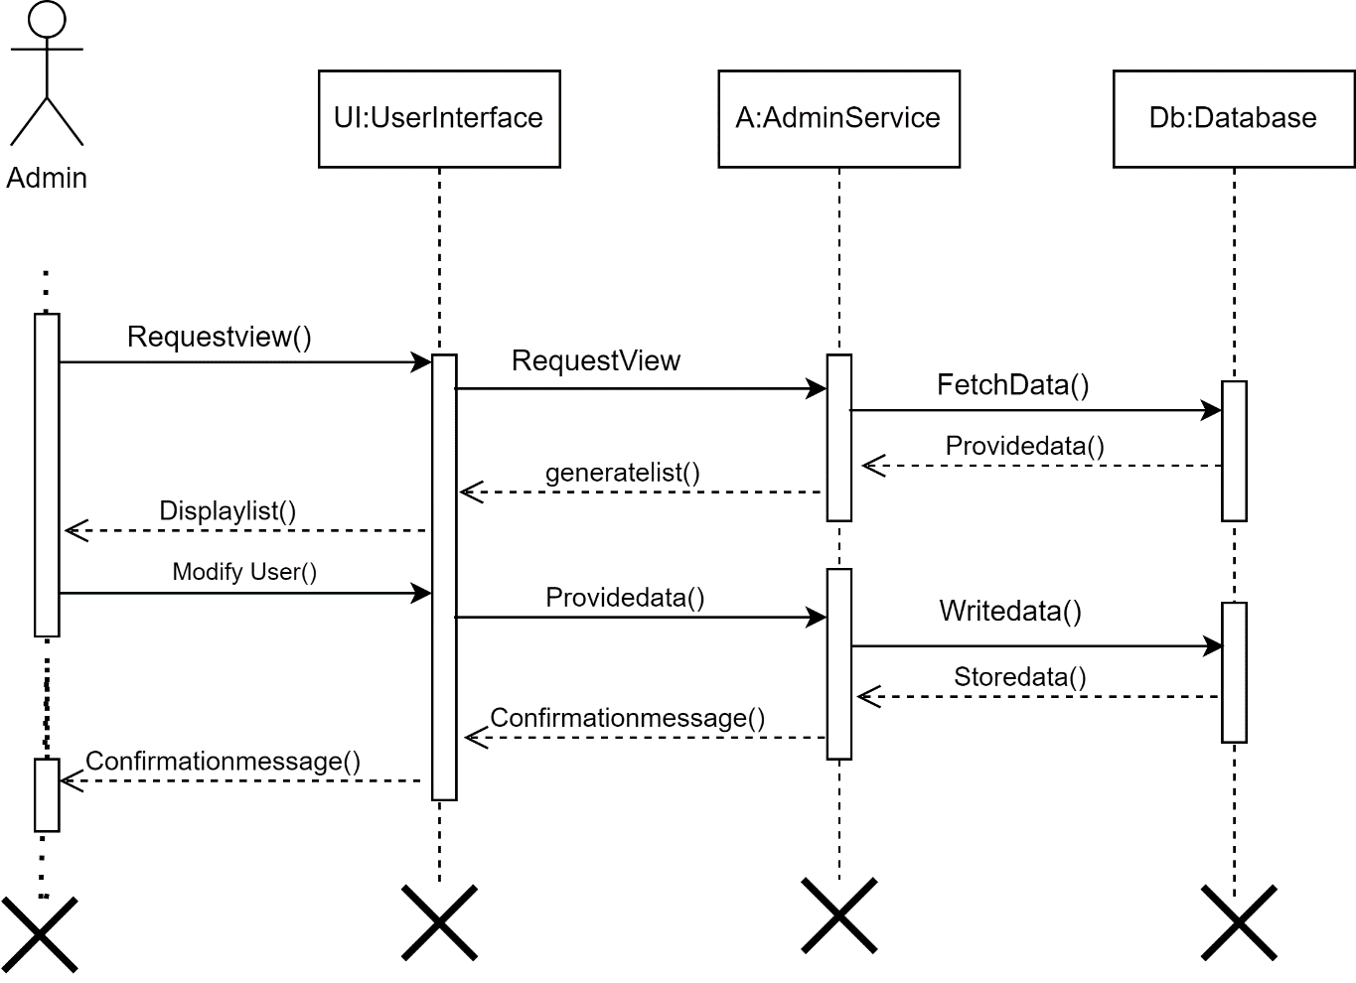

Figure 4.10:Sequence Diagram: Admin Manage User

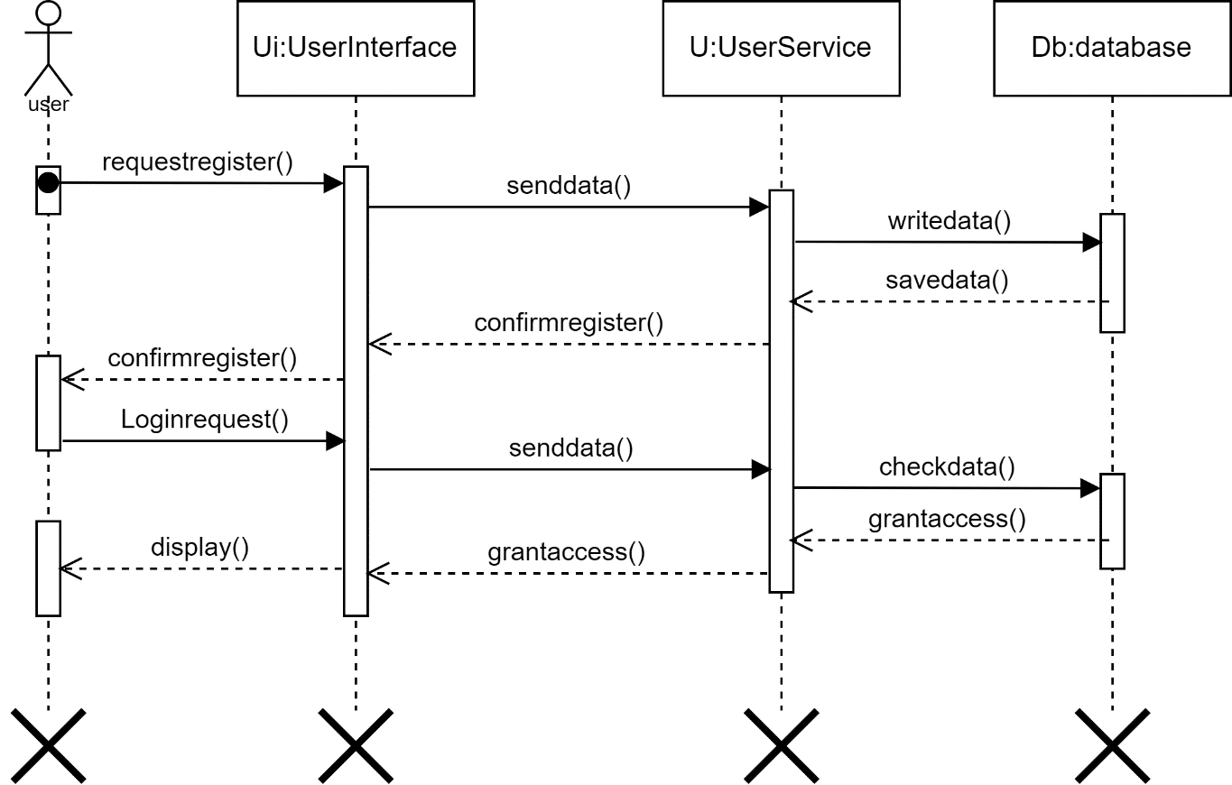
Figure 4.11:Sequence Diagram: User Registration/Login
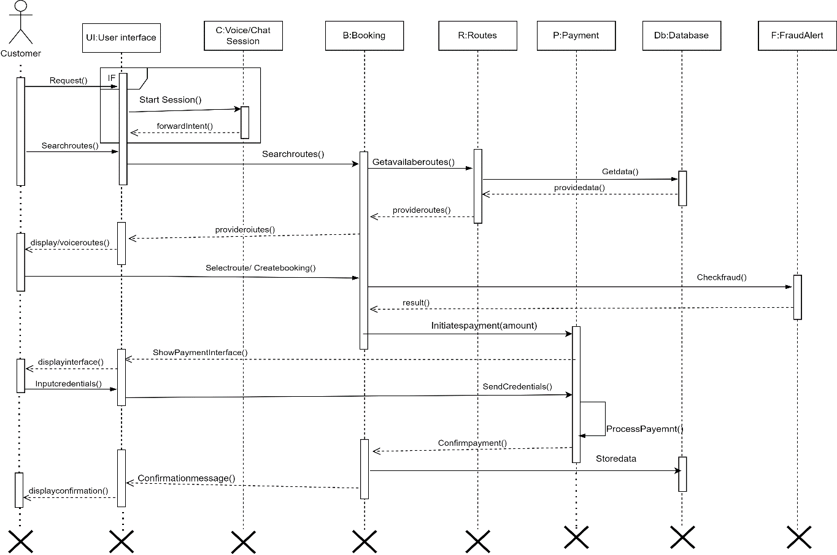
Figure 4.12:Sequence Diagram: Booking Ticket
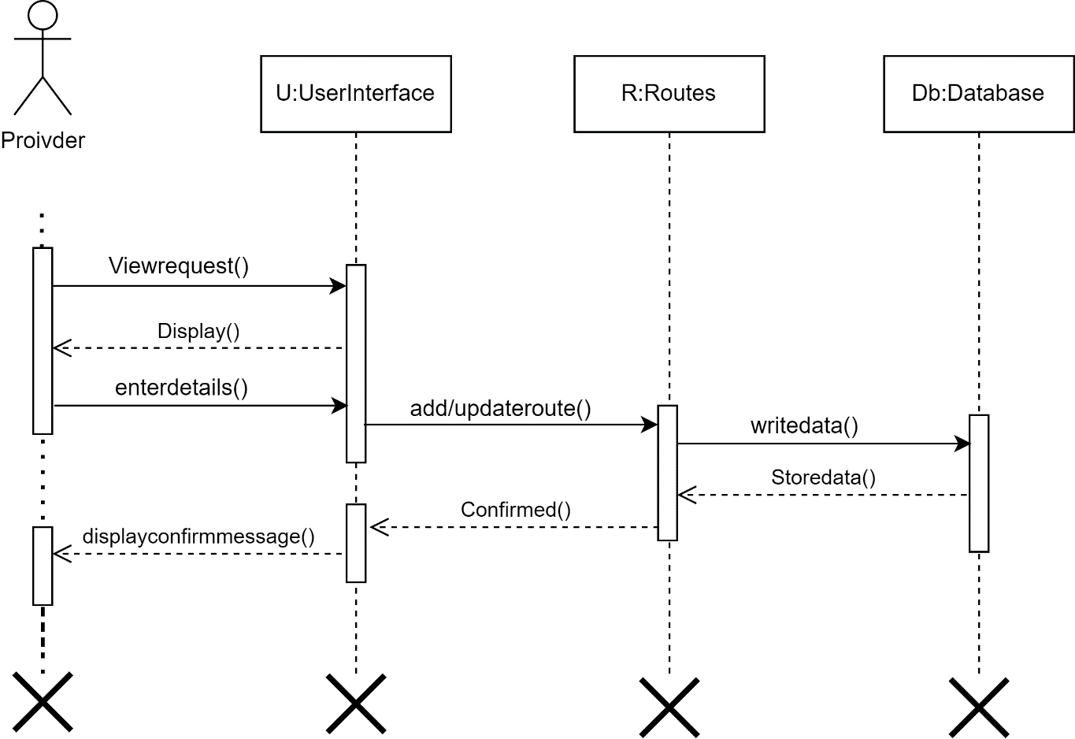
Figure 4.13:Sequence Diagram: Provider Manage Routes

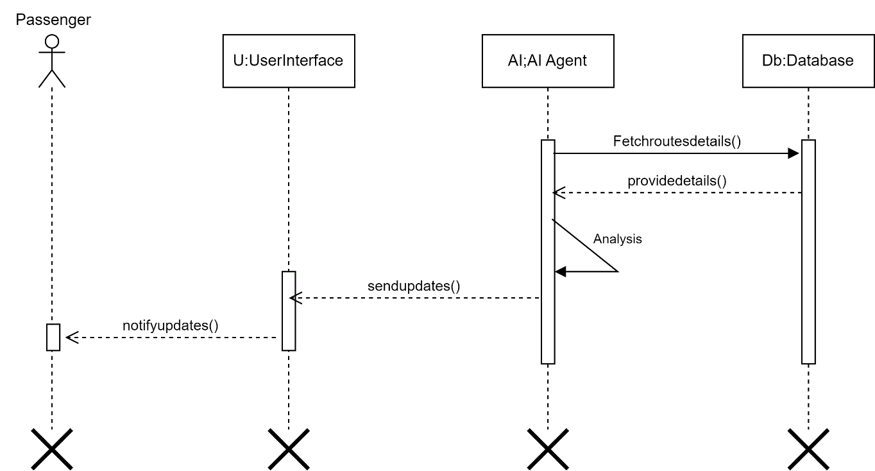
Figure 4.14:Sequence Diagram: Real Time Travel Updates

Collaboration Diagram
A collaboration diagram illustrates objects, their relationships, and the sequence of messages exchanged between them to achieve functionality.

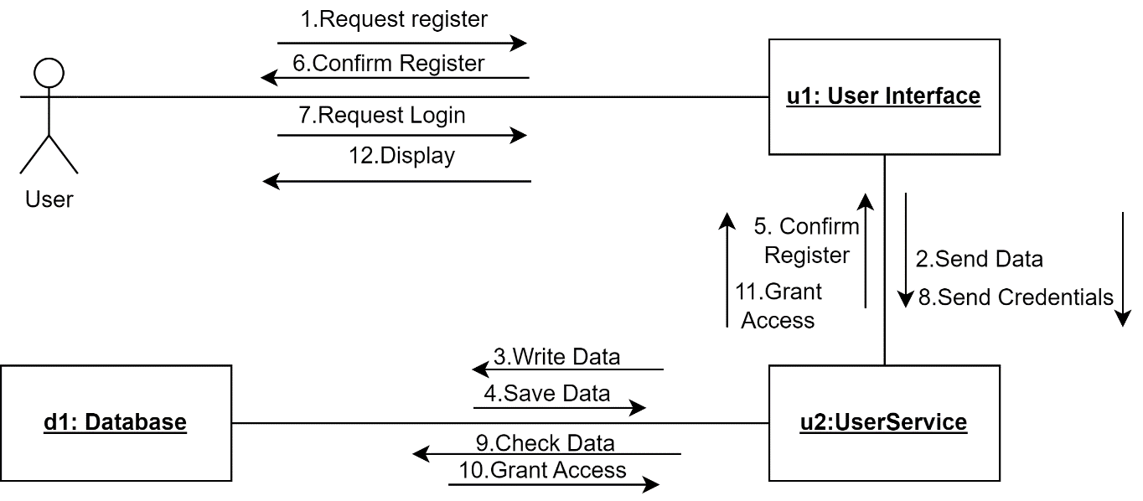
Figure 4.15:Collaboration Diagram: User registration/login

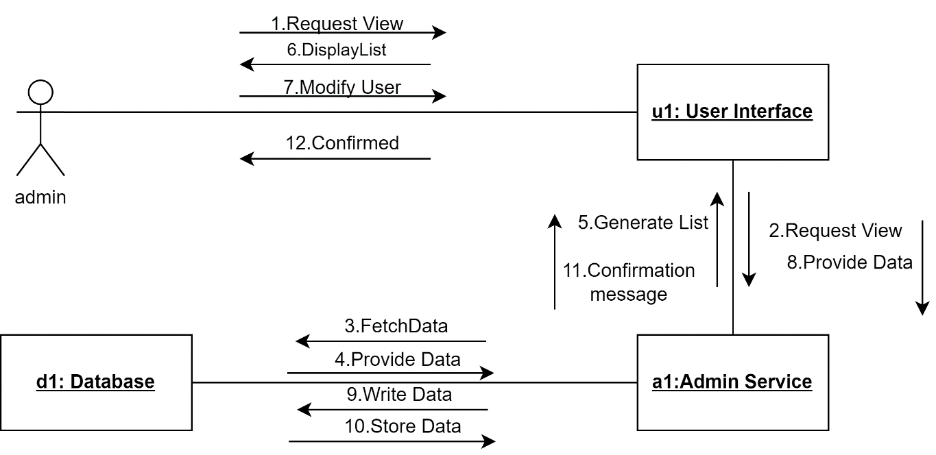

Figure 4.16:Collaboration Diagram: Admin Manage User

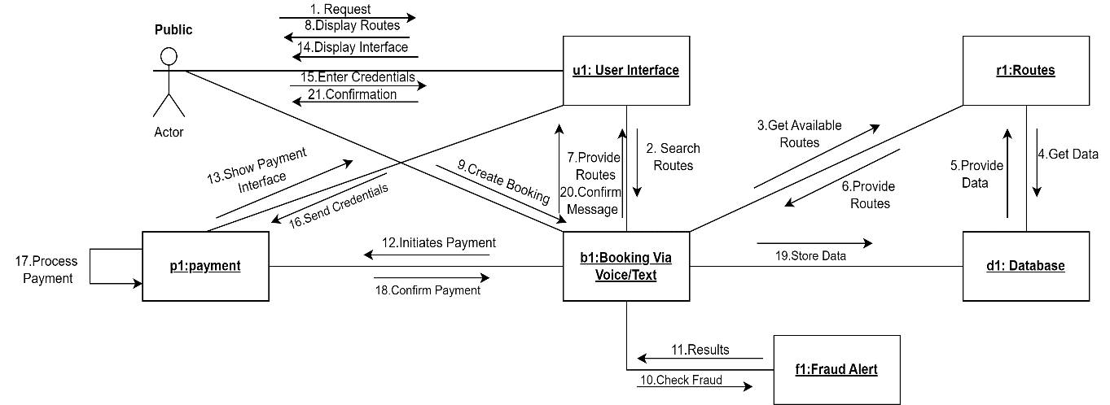

Figure 4.17:Collaboration Diagram: Booking Ticket

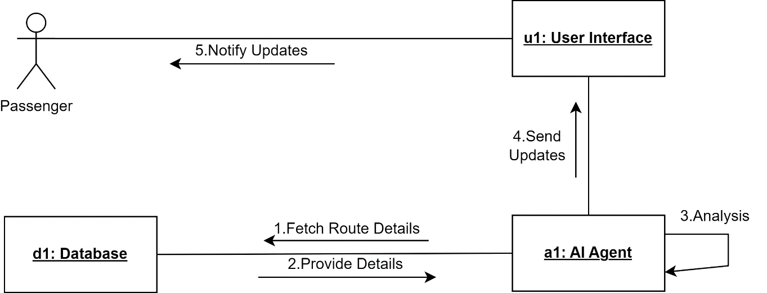

Figure 4.18:Collaboration Diagram: Real Time Travel Updates

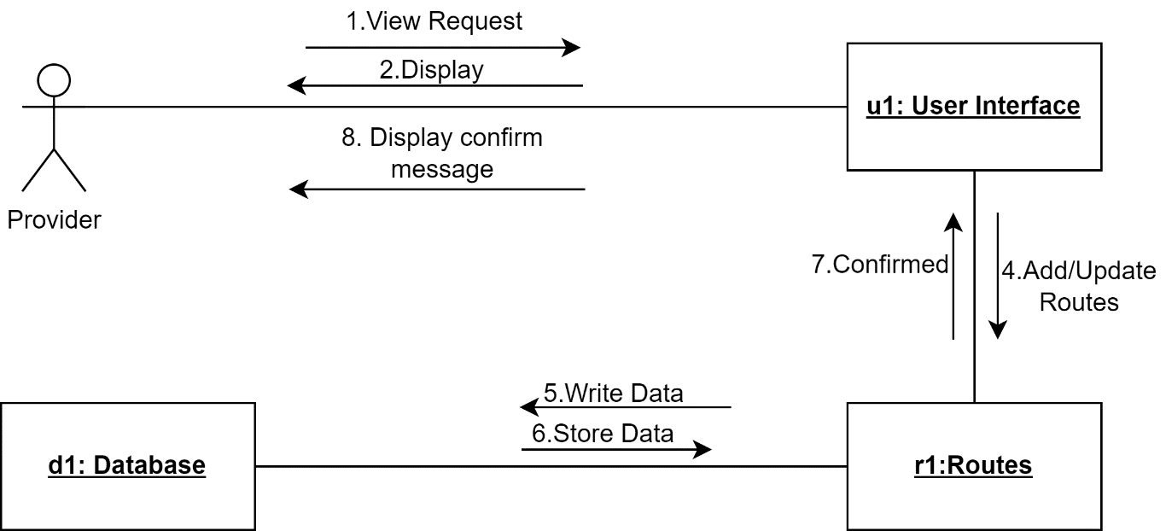
Figure 4.19:Collaboration Diagram: Provider Manage Routes

CHAPTER 5: IMPLEMENTATION
This chapter explains how the SafarBot system was practically developed and implemented. It describes the technologies used, system modules, communication methods, and how different components work together. The main goal of implementation was to build a simple, secure, and intelligent ticket booking system that can be easily used by all users, including uneducated and elderly people.

Communication Protocol Implementation
In the SafarBot web application, communication protocols define how different system components exchange data with each other. The React.js frontend communicates with the backend server using HTTP and HTTPS through RESTful APIs. All requests and responses are transferred securely in JSON format to ensure clarity, compatibility, and efficient data handling.
The backend server, developed using Node.js and Express.js, interacts with the MongoDB database using its native database protocol for storing and retrieving user data, bookings, routes, and fraud-related information. External services such as maps, weather, voice processing, and payment sandbox APIs are accessed using HTTP-based APIs.
These communication protocols ensure secure, reliable, and smooth interaction between all SafarBot components, even during high user activity.

Component Diagram
The component diagram illustrates the interaction between the SafarBot frontend, backend services, database, AI modules, and external APIs. It shows how user requests flow from the UI to backend services and how responses are returned after processing.
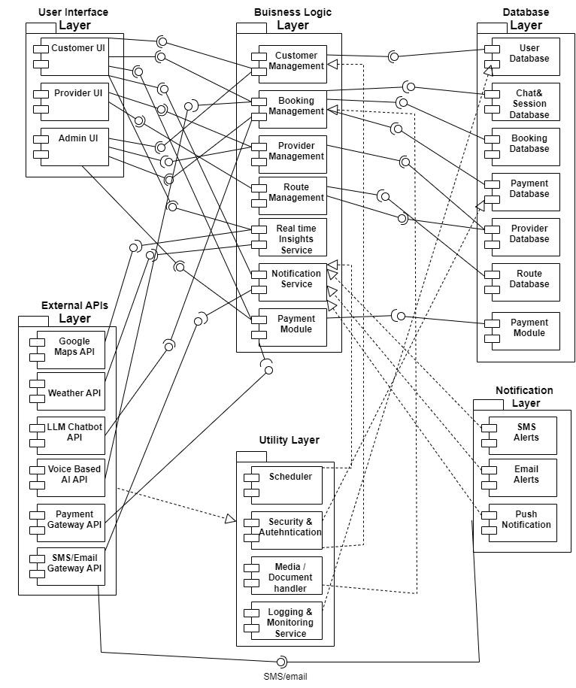
Figure 5.1:Component Diagram

Network and Protocol Choice

Communication Protocols
- HTTP/HTTPS Protocol
The Hypertext Transfer Protocol (HTTP) and its secure version HTTPS are used as the core communication protocols between the client and server components of SafarBot. These protocols follow a request–response model, where the client sends a request and the server responds with the required data.
HTTP/HTTPS is lightweight, platform-independent, and widely supported, making it suitable for web-based ticket booking systems accessed from both desktop and mobile devices.
- RESTful APIs
RESTful APIs are used to establish communication between the frontend, backend, database, AI services, and external systems. Standard HTTP methods such as GET, POST, PUT, and DELETE are used for retrieving, submitting, updating, and deleting data.
Data is exchanged in JSON format, which improves readability, interoperability, and scalability of the SafarBot system.
- Integration with External Services
SafarBot integrates external services such as Google Maps, weather APIs, speech-to-text services, and sandbox payment gateways using RESTful interfaces. These integrations enable real-time route visualization, travel updates, voice-based booking, and secure payment demonstrations without affecting system performance.

Security Considerations
- Authentication and Authorization
Authentication mechanisms ensure that only registered and valid users can access the system. Role-based authorization is implemented to differentiate access levels for passengers, transport providers, and administrators. This prevents unauthorized access to sensitive booking and user data.
- Data Security and Encryption
All sensitive data transmitted over the network is protected using secure HTTPS communication. User passwords and confidential information are encrypted before being stored in the database. This ensures data confidentiality and protects against data breaches.
- API Security and Input Validation
APIs are secured using authentication tokens to prevent unauthorized requests. Input validation techniques are applied to protect the system from malicious inputs such as injection attacks. These measures enhance overall system security and reliability.

Performance Optimization
- Efficient Data Processing
The system uses optimized database queries to reduce response time and server load. Only required data is fetched and processed, which improves system speed during peak booking times.
- Caching and Load Management
Caching techniques are applied for frequently accessed data such as routes and schedules. This reduces repeated database access and improves response time. Load management strategies ensure system stability during high user traffic.
- Scalability and Network Efficiency
The SafarBot architecture supports scalability to handle an increasing number of users and bookings. Efficient API calls reduce network latency and bandwidth usage, ensuring consistent performance during peak usage periods.

Choice of Object Middleware

User Management Module
Objects Used:
User objects store information such as name, email, role, and login credentials. These objects manage different user types including passengers, transport providers, and administrators. Object-oriented design improves data organization and code reusability.
Middleware Used:
Authentication middleware verifies user identity before granting system access. Authorization middleware enforces role-based access control. This separation of logic improves security and maintainability.

Ticket Booking Module
Objects Used:
Booking objects store ticket details such as route, seat number, travel date, and payment status. These objects represent real-world booking transactions and allow structured data handling.
Middleware Used:
Validation middleware checks the completeness and correctness of booking requests. Error-handling middleware manages invalid inputs and system exceptions, ensuring reliable booking operations.

Real Time Travel Insights Module
Objects Used:
Map objects are responsible for analyzing route-related data such as travel paths, traffic conditions, and pickup points. These objects generate processed travel insights and forward the results to passengers through the user interface.

Middleware Used:
Middleware handles the communication between map services and the system. It collects real-time map data, processes and formats the information, and ensures that the generated results are delivered accurately to the passenger interface.

User Interface
The ticket booking user interface is designed to be simple, clear, and user-friendly. Users can book tickets by selecting routes, seats, and travel dates through an easy-to-understand layout. Voice-based booking allows users to interact with the system without typing.
Clear labels, icons, and validation messages guide users throughout the booking process. Mandatory fields are highlighted to prevent incomplete submissions, ensuring accurate booking-data.

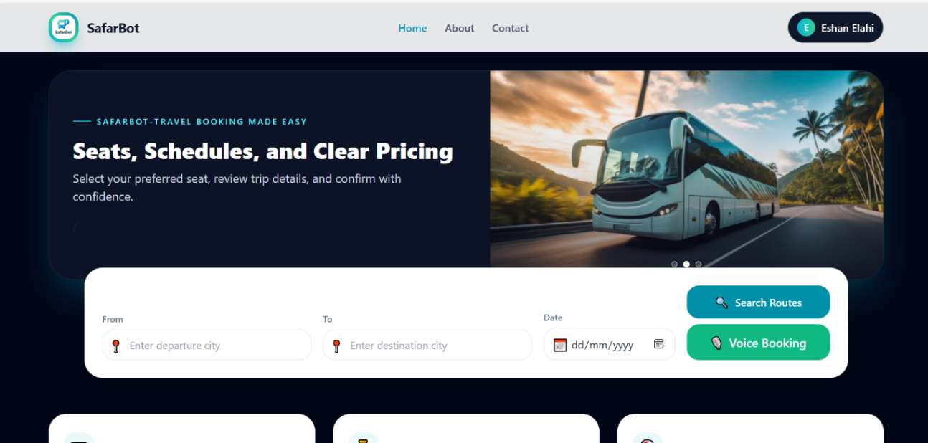
Figure 5.2:Home Page
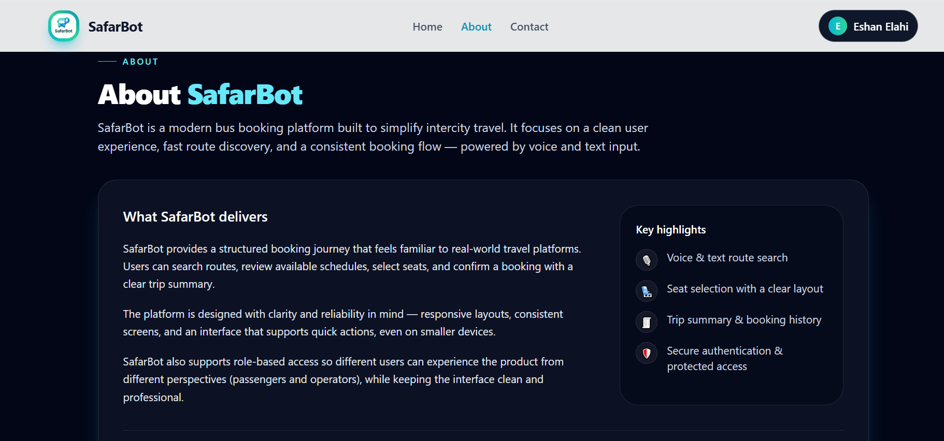
Figure 5.3:About Page

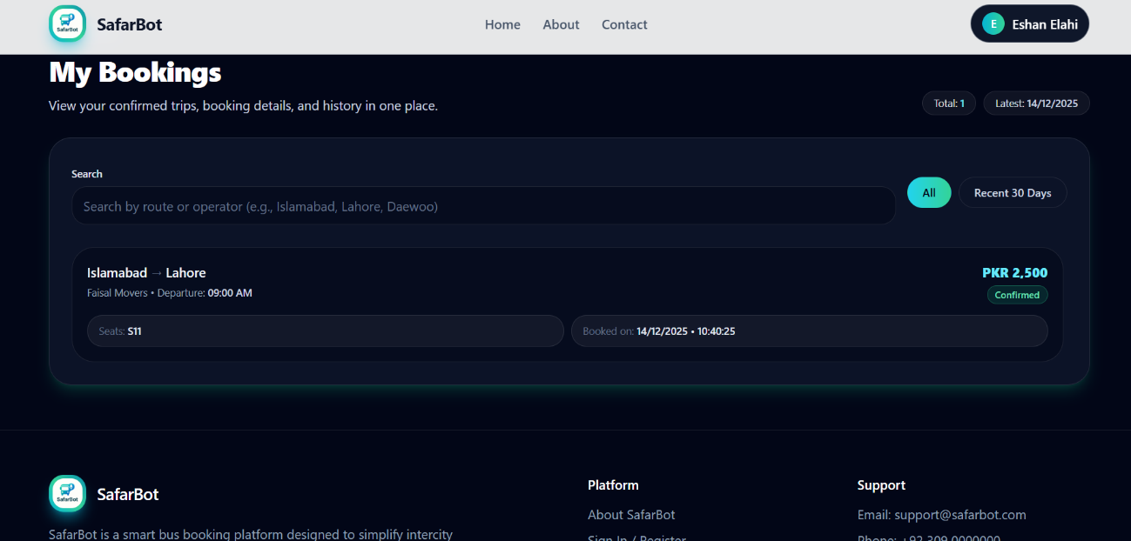
Figure 5.4:View Bookings
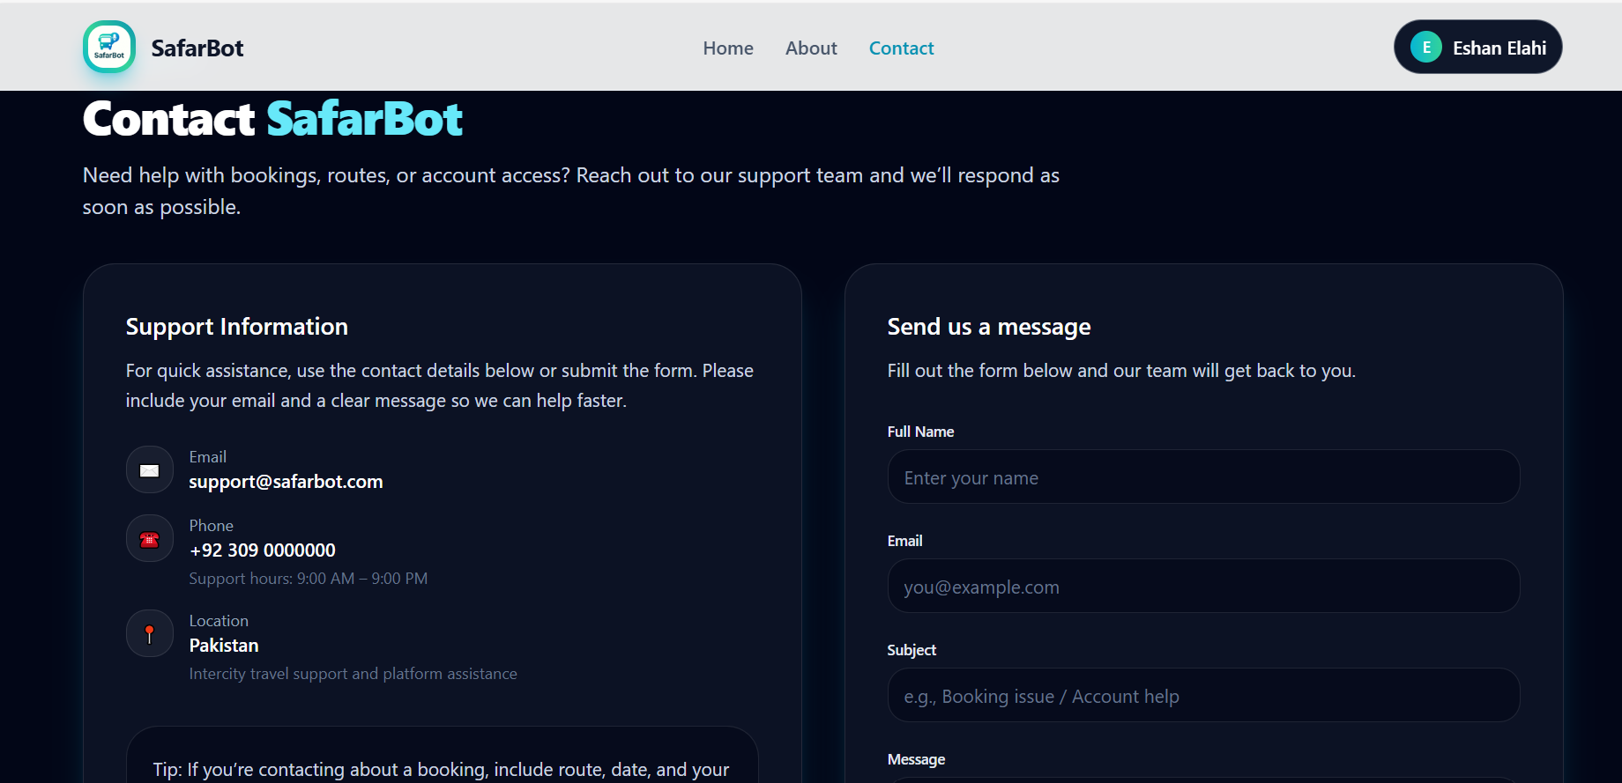
Figure 5.5:Contact Page

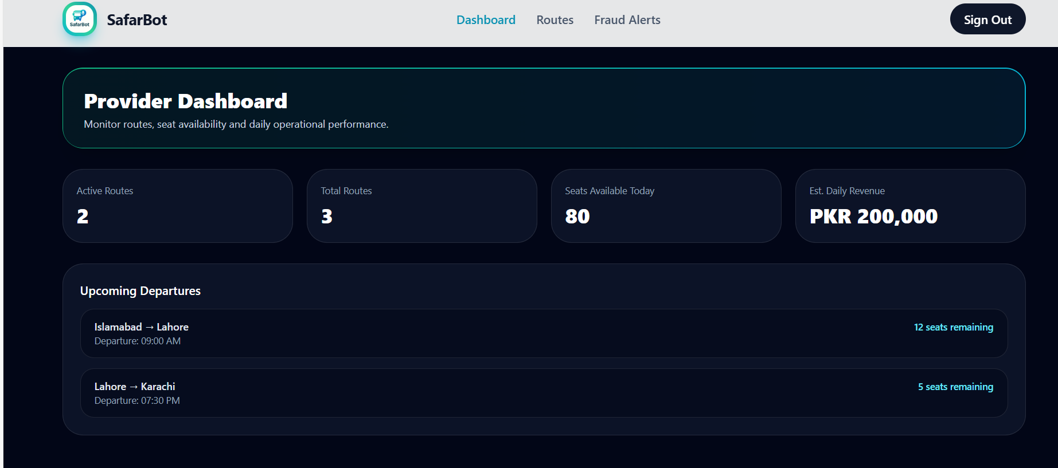
Figure 5.6:Provider Dashboard
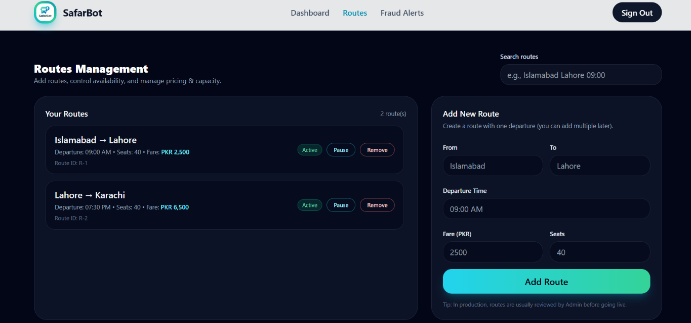
Figure 5.7:Routes Manage

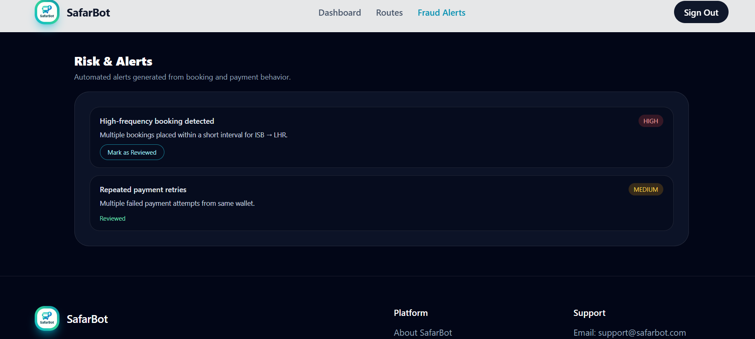
Figure 5.8:Fraud Alert
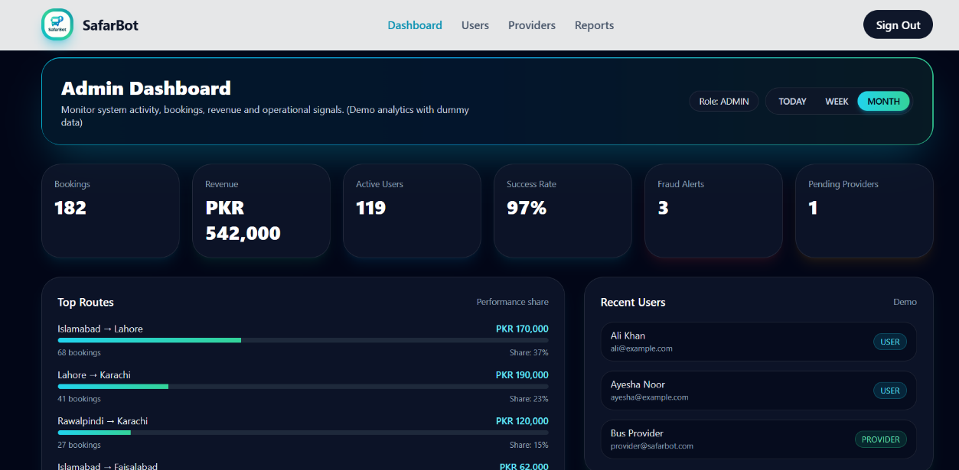
Figure 5.9:Admin Dashboard

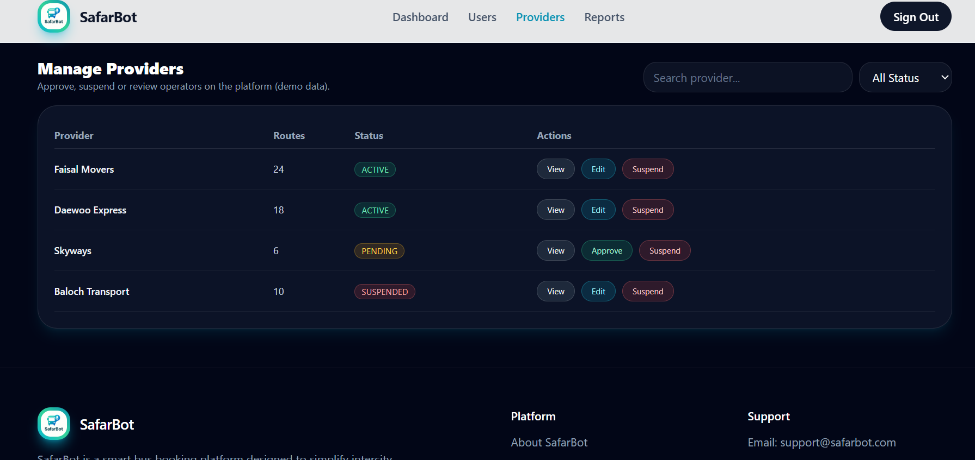
Figure 5.10:Manage Provider
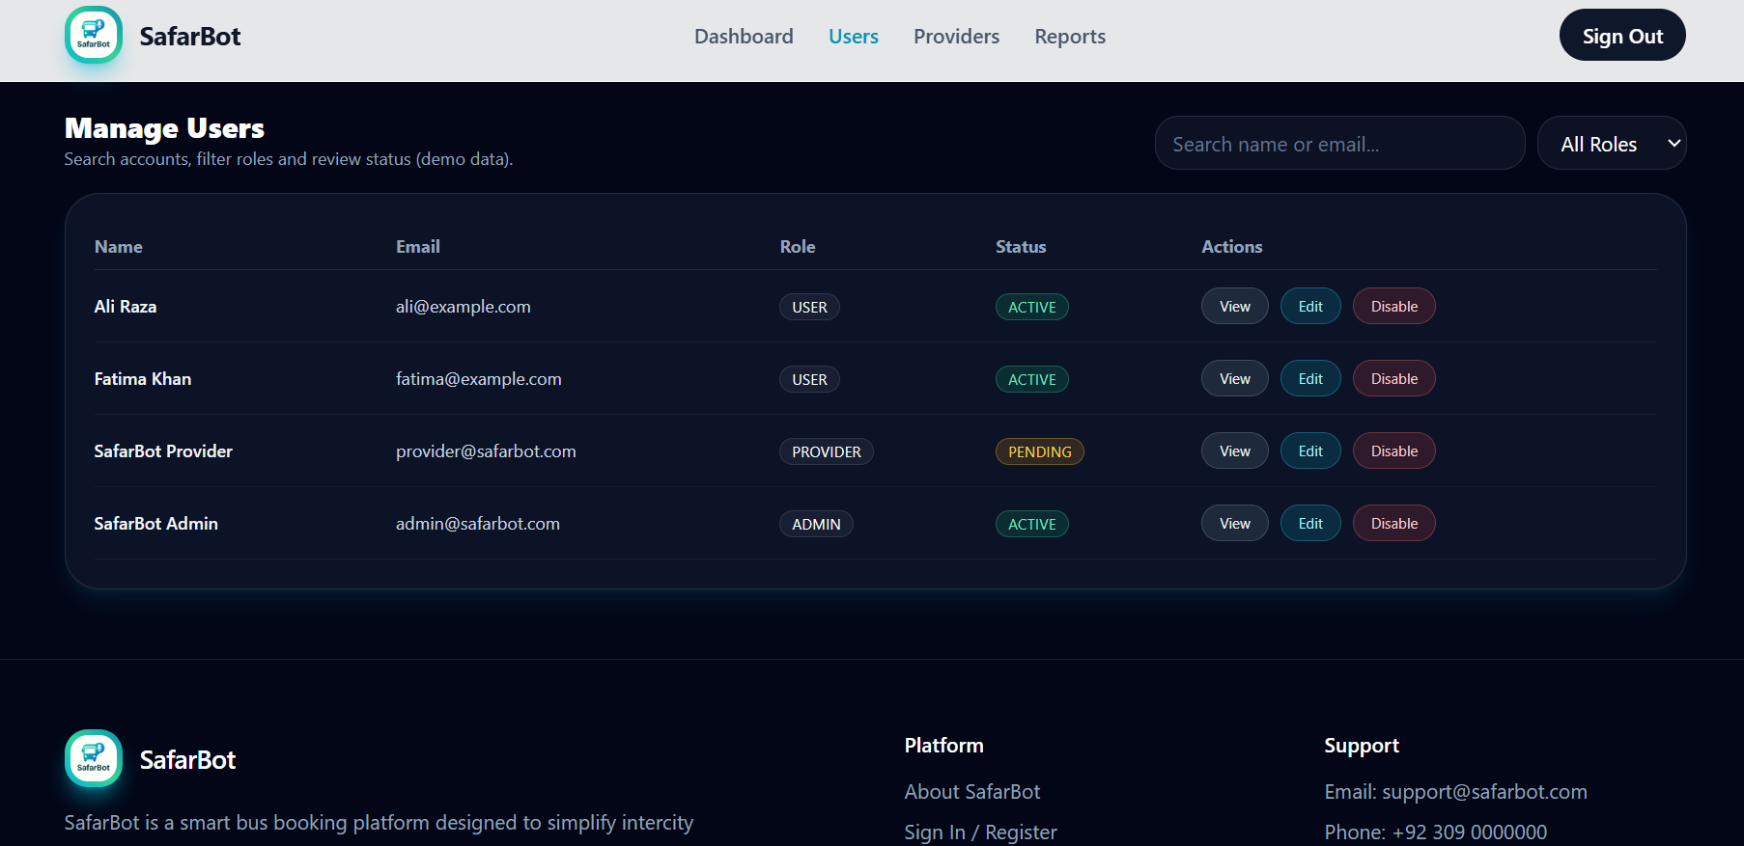
Figure 5.12:Manage User

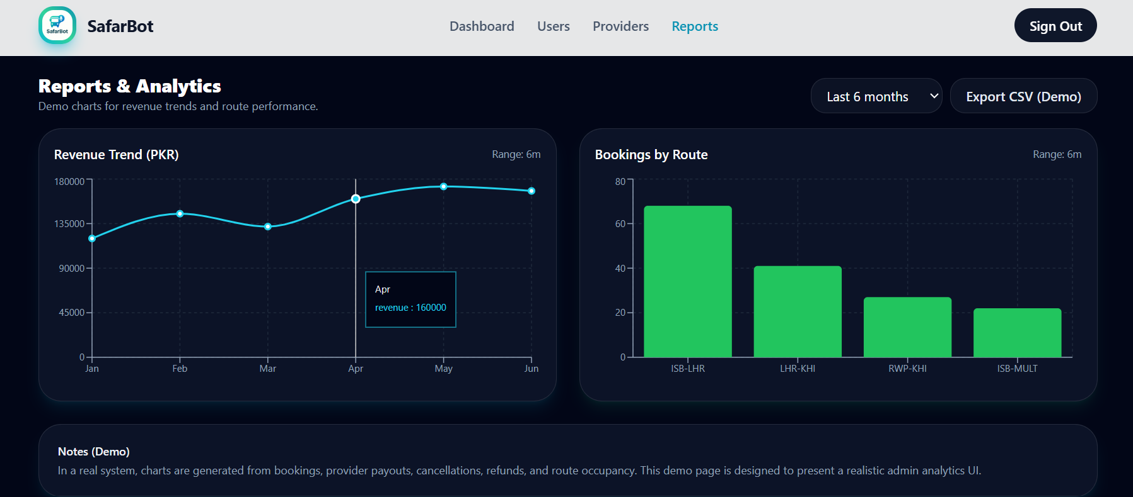
Figure 5.13:View Reports
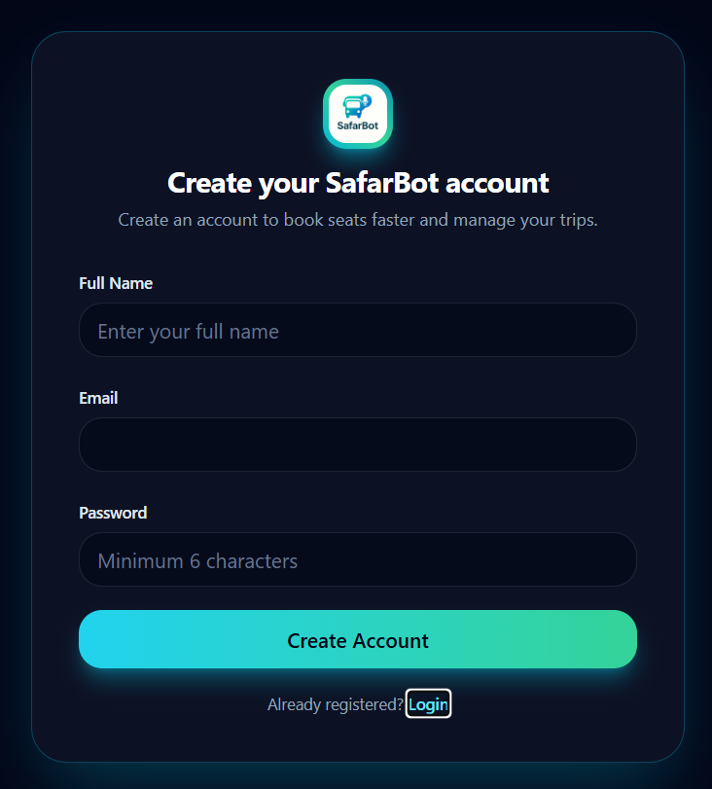
Figure 5.14:Register Page

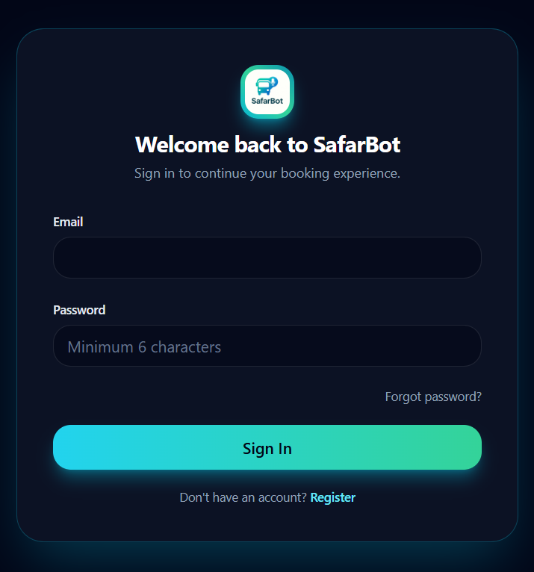
Figure 5.15:Login Page

CHAPTER 6: TESTING AND EVALUATION
This chapter discusses the testing and evaluation of the SafarBot system. Testing was performed to ensure that all system features work correctly, meet requirements, and provide a smooth user experience. Different testing techniques were applied at various stages of development.

Verification
Verification ensures that the system is built correctly according to the approved requirements, design specifications, and proposal.

User Module Verification
- User registration and login features match the project proposal.
- Authentication and authorization rules are properly implemented.
- No required user functionality is missing.

Ticket Booking & Route Module Verification
- Ticket booking, route selection, and seat management meet system specifications.
- Data flow between booking, payment, and database modules is correct.
- Design and functional requirements are fully fulfilled.

Provider & Notification Module Verification
- Transport provider features follow the approved system design.
- Notifications behave according to documented workflows.
- Security standards are properly implemented.

AI Module Verification
- AI-based features such as fraud detection and chat support meet defined requirements.
- Decision logic follows the designed AI model.
- Outputs are consistent and reliable.

Validation
Validation ensures that the system fulfills user needs and real-world usage expectations.

User Validation
- The system satisfies passenger and provider needs.
- Real-world booking scenarios work successfully.
- Users trust the system for ticket booking and payments.

Functional Validation
- All system modules work together correctly.
- The system performs according to expectations.
- Project objectives are successfully achieved.

Performance Validation
- The system performs efficiently under normal and high usage.
- Response time remains acceptable during peak booking hours.
- System reliability is confirmed through repeated testing.

Usability Testing
Usability testing ensures ease of use and accessibility for all users.

User Interface Usability
- The interface is easy to understand and navigate.
- Buttons, icons, and instructions are clear.
- Users can operate the system without prior training.

Ticket Booking Usability
- Booking steps are simple and straightforward.
- Minimum user input is required.
- Users can complete ticket bookings easily.

Route & Notification Usability
- Routes and schedules are clearly displayed.
- Notifications are noticeable and understandable.
- Users quickly grasp important travel information.

Provider Dashboard Usability
- Dashboard layout is clean and user-friendly.
- Booking and route management tasks are clearly shown.
- Navigation between features is smooth.

Unit Testing
Each module was tested independently to ensure correctness.

User Registration & Authentication Module
- Signup and login functions are tested individually.
- Valid and invalid credentials are verified.
- Authentication logic works correctly.

Ticket Booking Module
- Each booking function is tested independently.
- Route selection, seat availability, and payment inputs are validated.
- Errors are handled properly.

Real Time Travel Insights Module
- Map rendering is optimized and tested for real-time updates.
- Routes, pickup points, and vehicle positions are displayed live and accurately.
- API responses are processed instantly to reflect current traffic and travel conditions.

Provider Management Module
- Provider registration and management functions are unit tested.
- Route creation and schedule logic is verified.
- Duplicate or invalid entries are prevented.

AI Fraud Detection Module
- Fraud detection logic is tested using sample booking data.
- Alerts are generated correctly.
- Invalid data is handled safely.

Notification Module
- Notification trigger functions are tested.
- Correct message formats are verified.
- Failures are handled without system crashes.

Integration Testing
Integration testing ensures smooth interaction between modules.

User Login & Ticket Booking Integration
- Only authenticated users can book tickets.
- Booking data flows correctly between modules.

Ticket Booking & Routes Integration
- Booked routes appear correctly on maps.
- Location data integrates properly with mapping services.
- Map updates occur without delay.

AI Fraud Detection & Booking Integration
- Fraud analysis integrates with the booking process.
- Suspicious activities are flagged correctly.
- System responses remain accurate.

Provider Management & Booking Integration
- Provider schedules integrate with user bookings.
- Seat availability updates correctly.
- Coordination remains consistent.

Notification & Booking Integration
- Notifications trigger after bookings or changes.
- Relevant users receive accurate messages.
- Delivery is reliable.

Database & Backend Integration
- All modules interact correctly with the database.
- Data consistency is maintained.
- No data loss occurs.

System Testing
Complete system testing validates end-to-end workflows.

User Registration & Login Module
- Users can register and log in successfully.
- Secure access is ensured for passengers, providers, and admins.

Ticket Booking Module
- Users can book tickets without errors.
- Booking details are stored accurately.
- Invalid inputs are handled properly.

Route & Map Module
- Routes and travel paths display correctly.
- Real-time updates work as expected.

Provider Management Module
- Providers can manage routes and schedules.
- Duplicate or incorrect entries are prevented.

AI Module
- AI features operate correctly.
- Errors and missing data are handled safely.

Acceptance Testing
Acceptance testing confirms system readiness for real-world use.

User Module Acceptance
- Users confirm easy registration and login.
- System usability is approved.

Ticket Booking Acceptance
- Users find the booking process simple.
- Tickets appear correctly after booking.

Route Map Acceptance
- Routes are clear and understandable.
- System is accepted for real use.

Provider Module Acceptance
- Providers confirm correct schedule and seat management.
- Response time is acceptable.

AI Module Acceptance
- AI outputs are understandable.
- Fraud alerts support decision-making.

Stress Testing

High User Load Testing
- The system is tested with many simultaneous users.
- Performance remains stable during peak booking times.

Multiple Booking Requests
- Stress testing checks system behavior under heavy booking activity.
- Database handles large data volumes efficiently.

Notification Load Testing
- System sends notifications to a large number of users simultaneously.
- Delivery remains timely without failures.

AI Processing Load
- AI processing are tested under heavy load.
- Accuracy and response time remain acceptable.

Hardware Configuration for Testing

Client-Side Hardware
- Intel Core i5 or above
- Minimum 8 GB RAM
- Stable internet connection

Server-Side Hardware
- Cloud server with minimum 8 GB RAM
- Multi-core processor
- SSD storage

Network Requirements
- High-speed internet for real-time operations
- Tested under low and high bandwidth conditions

Evaluation

System Evaluation – Safarbot
The evaluation of SafarBot is conducted to ensure that the system meets its objectives, performs reliably, and provides efficient ticket booking services.
- User Module Evaluation
Users can register and log in easily. Secure role-based access is maintained.
- Ticket Booking Module Evaluation
Bookings are completed successfully. Data accuracy and validation are confirmed.
- Route & Map Module Evaluation
Routes are displayed clearly and updated in real time.
- Provider Module Evaluation
Providers manage routes and schedules effectively.
- AI Module Evaluation
Fraud detection improves booking security.
- Notification Module Evaluation
Users receive timely and accurate notifications.
- Database & Backend Evaluation
Data storage is secure and reliable.
- Performance Evaluation
System remains responsive under heavy usage.
- Usability Evaluation
Users can operate the system without training.
- Overall System Evaluation
SafarBot successfully meets all project objectives.

Deployment
SafarBot is deployed in a cloud-based environment to ensure availability, scalability, and security.
- Frontend deployed on web hosting platform
- Backend deployed on secure cloud server
- Database hosted on cloud database service
- AI services deployed server-side
- Notification services configured
Security, monitoring, and final deployment verification ensure readiness for real-world use.

Maintenance
System maintenance ensures long-term reliability and performance.
- Corrective maintenance fixes errors
- Adaptive maintenance supports new features
- Preventive maintenance reduces failures
- Perfective maintenance improves usability
- Database and security maintenance ensure safety
- AI models are updated regularly
- Monitoring ensures uninterrupted service

